
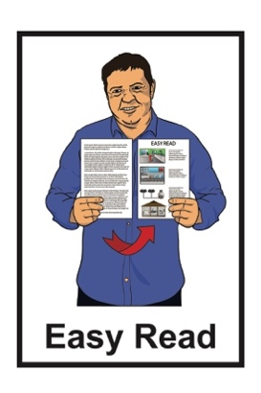

Summary: Improving the

Total Mobility scheme

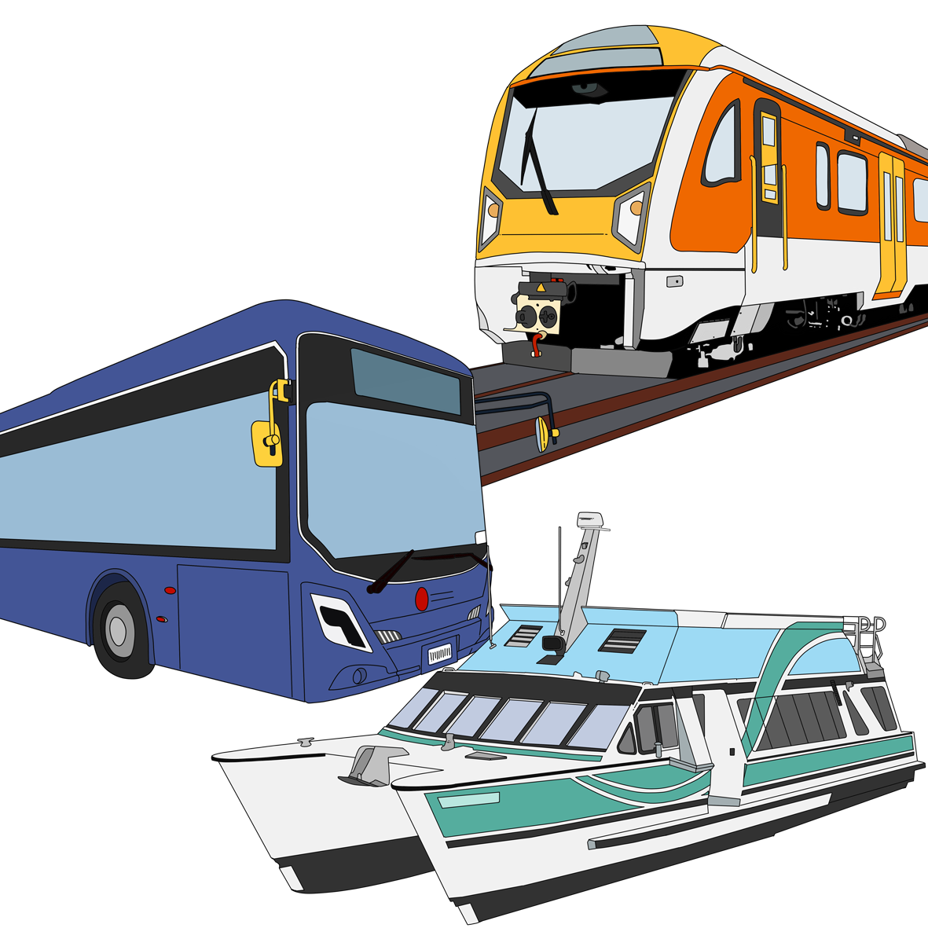
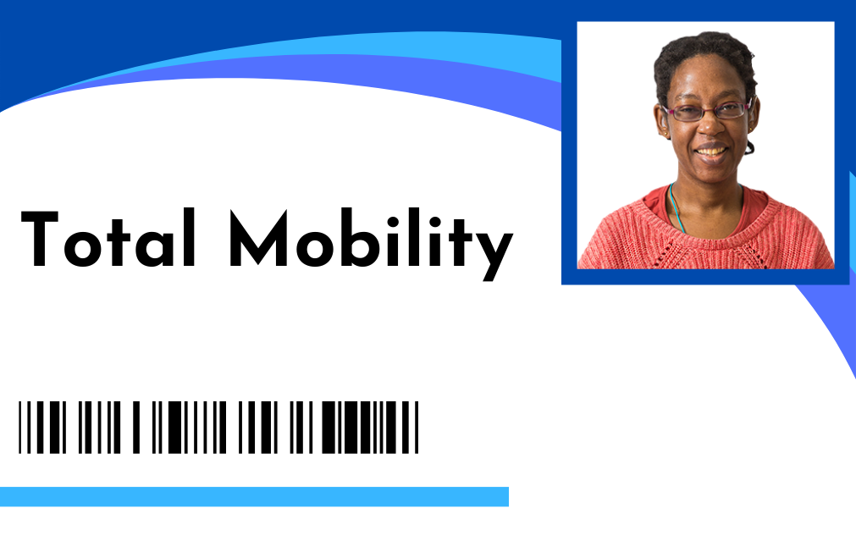
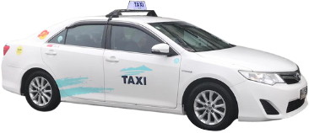

Published: December 2025

What you will find in here


Page number:

About this Easy Read 3

About Total Mobility 9


Total Mobility review 12

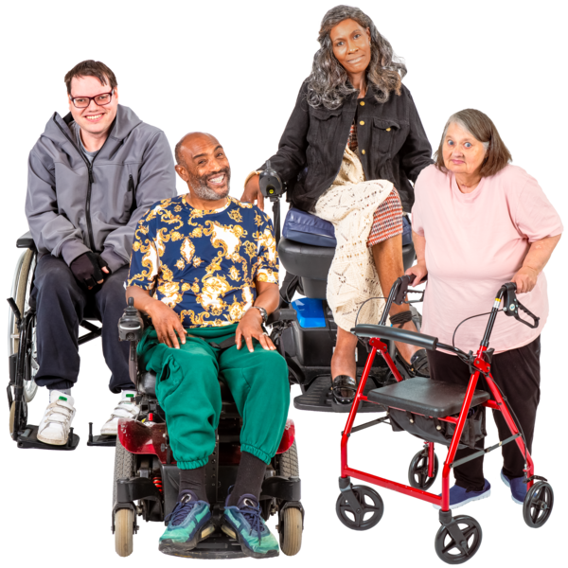
Changes that have just
happened 16


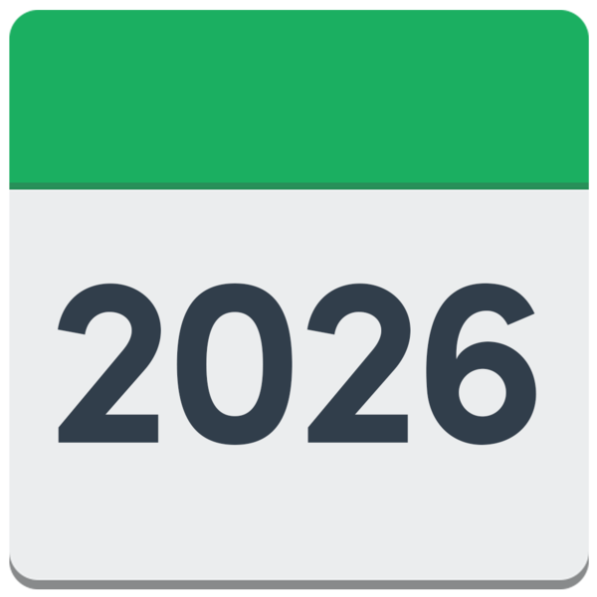
What will change from July 2026 19


Proposals to make Total Mobility stronger 21

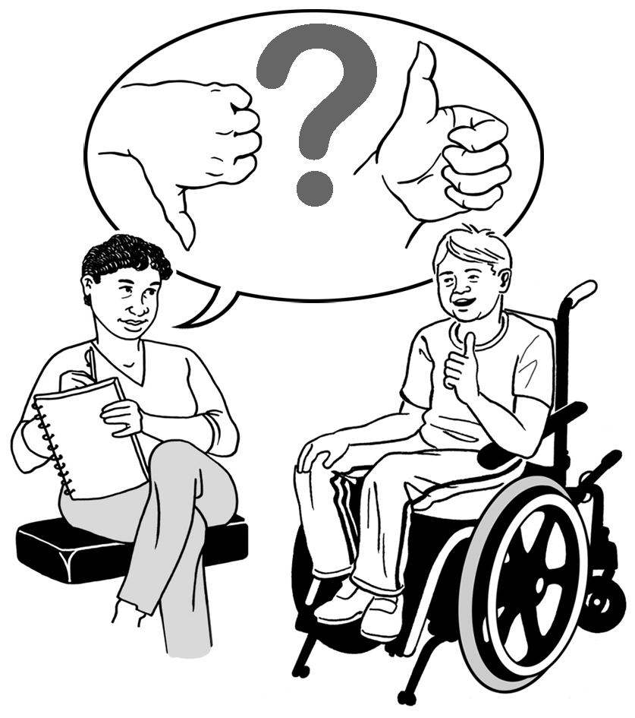
How to have your say 33

Before you start

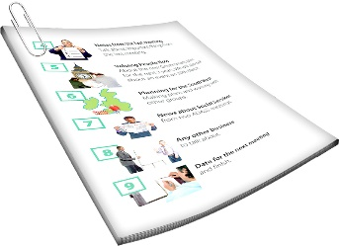
This is a long document.

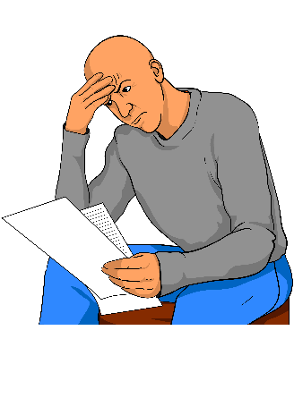
It can be hard for some people to read a document this long.

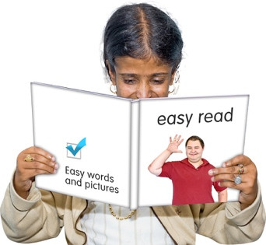
Some things you can do to make it easier are:
read it a few pages at a time
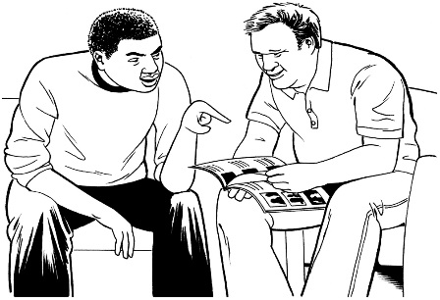
set aside some quiet time to look at it
have someone read it with you to support you to understand it.

About this Easy Read


This Easy Read is from the Ministry of Transport Te Manatū Waka.

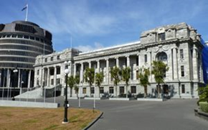
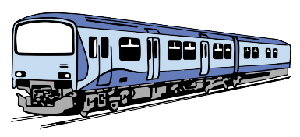
The Ministry of Transport Te Manatū Waka is the part of the Government in charge of the Aotearoa New Zealand transport system.


In this document the Ministry of Transport Te Manatū Waka will be called the Ministry of Transport.

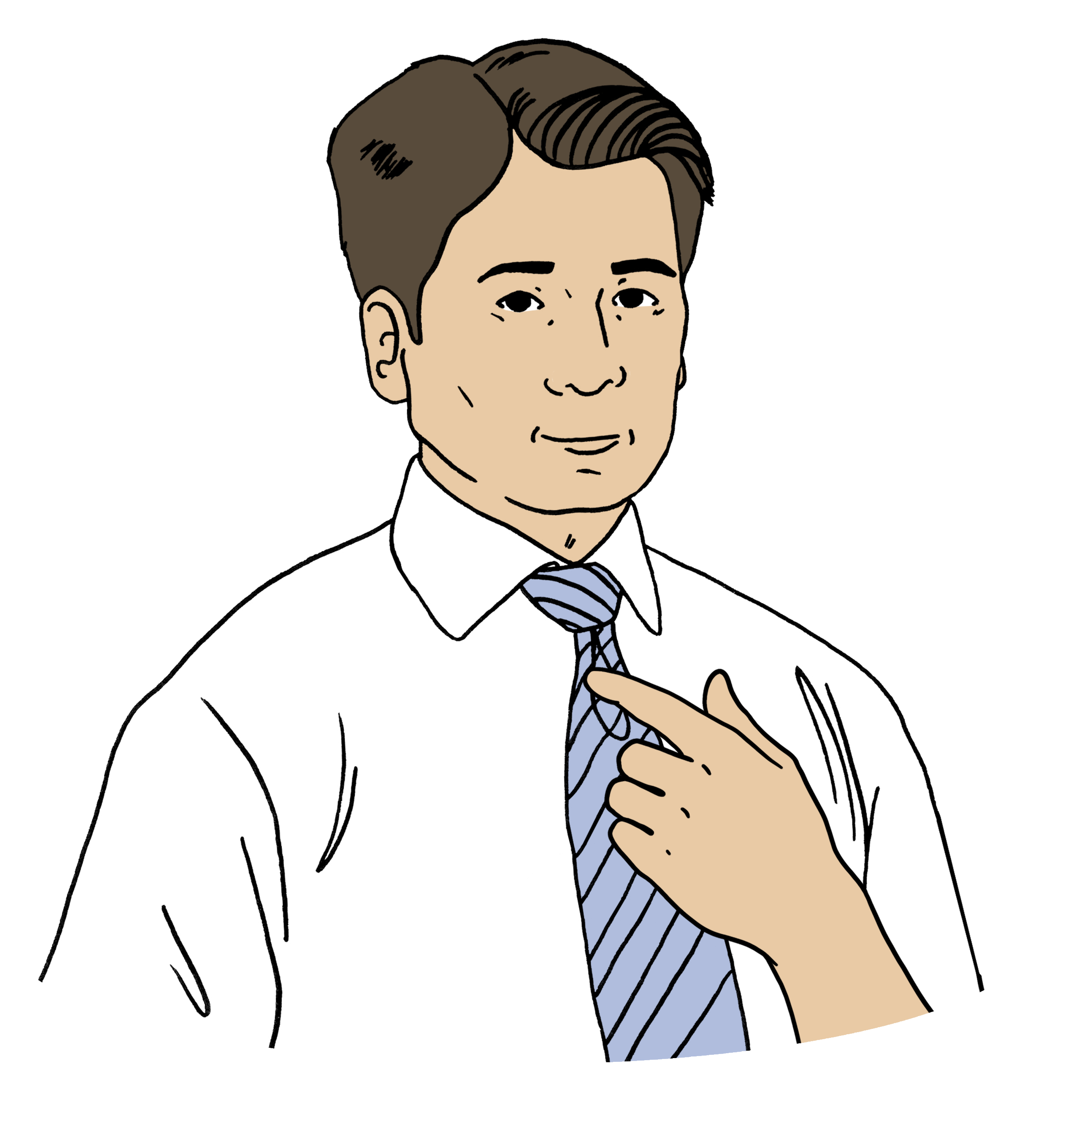
Where it says we / us this means
the Ministry of Transport.
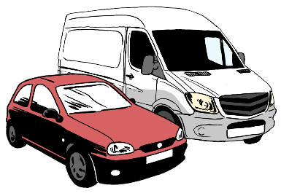
The transport system means anything that moves:
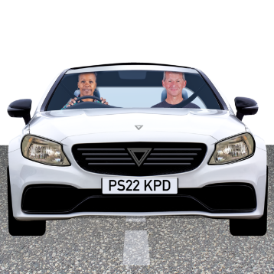
people around the country
things around the country.

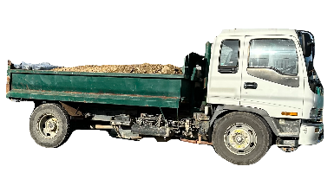
Some parts of the transport system are:
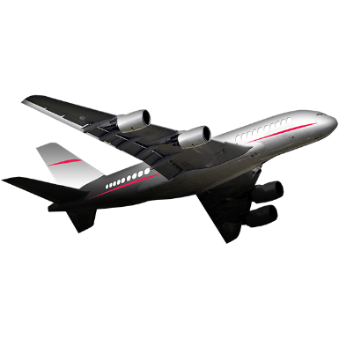
roads
trucks
trains
planes
boats.

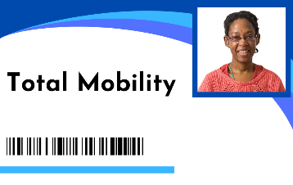
This Easy Read is a summary of the improvements that are being talked about for Total Mobility.

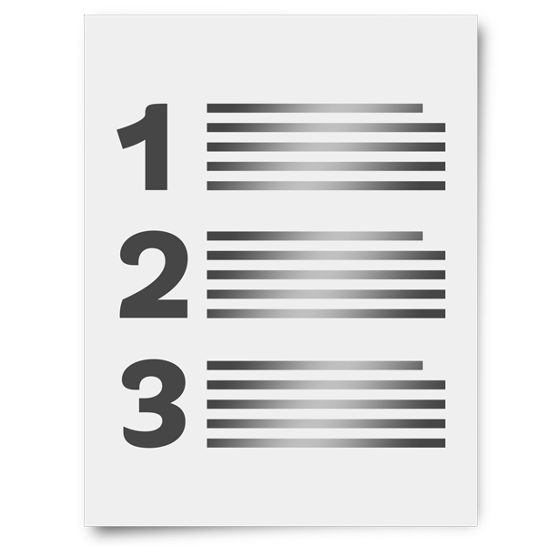
A summary is:
shorter than the original document
tells you the main points.

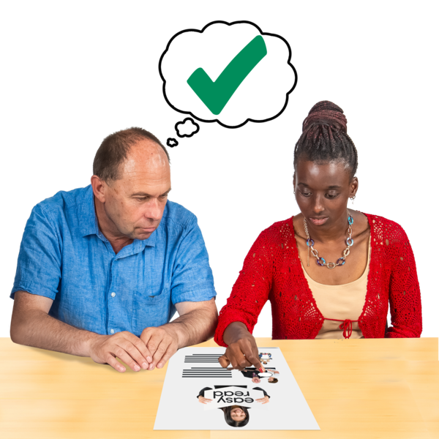
Improvements means to:
change things
make things better.

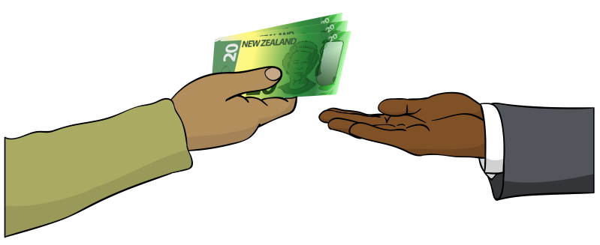
Total Mobility is a scheme that
supports disabled people to move around by paying part of the cost of taxi trips.

Disabled people can use Total Mobility if they cannot use public transport on their own.

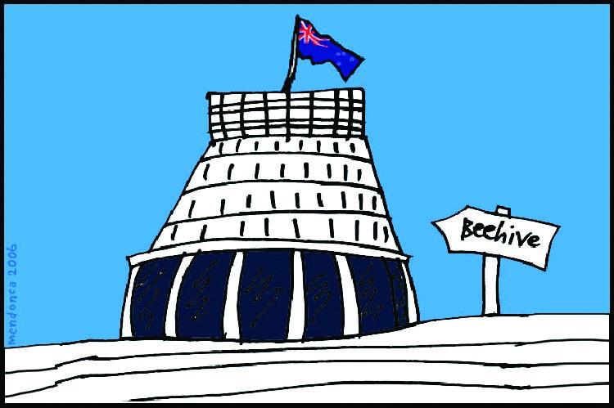
Some of the money for the Total Mobility scheme comes from:
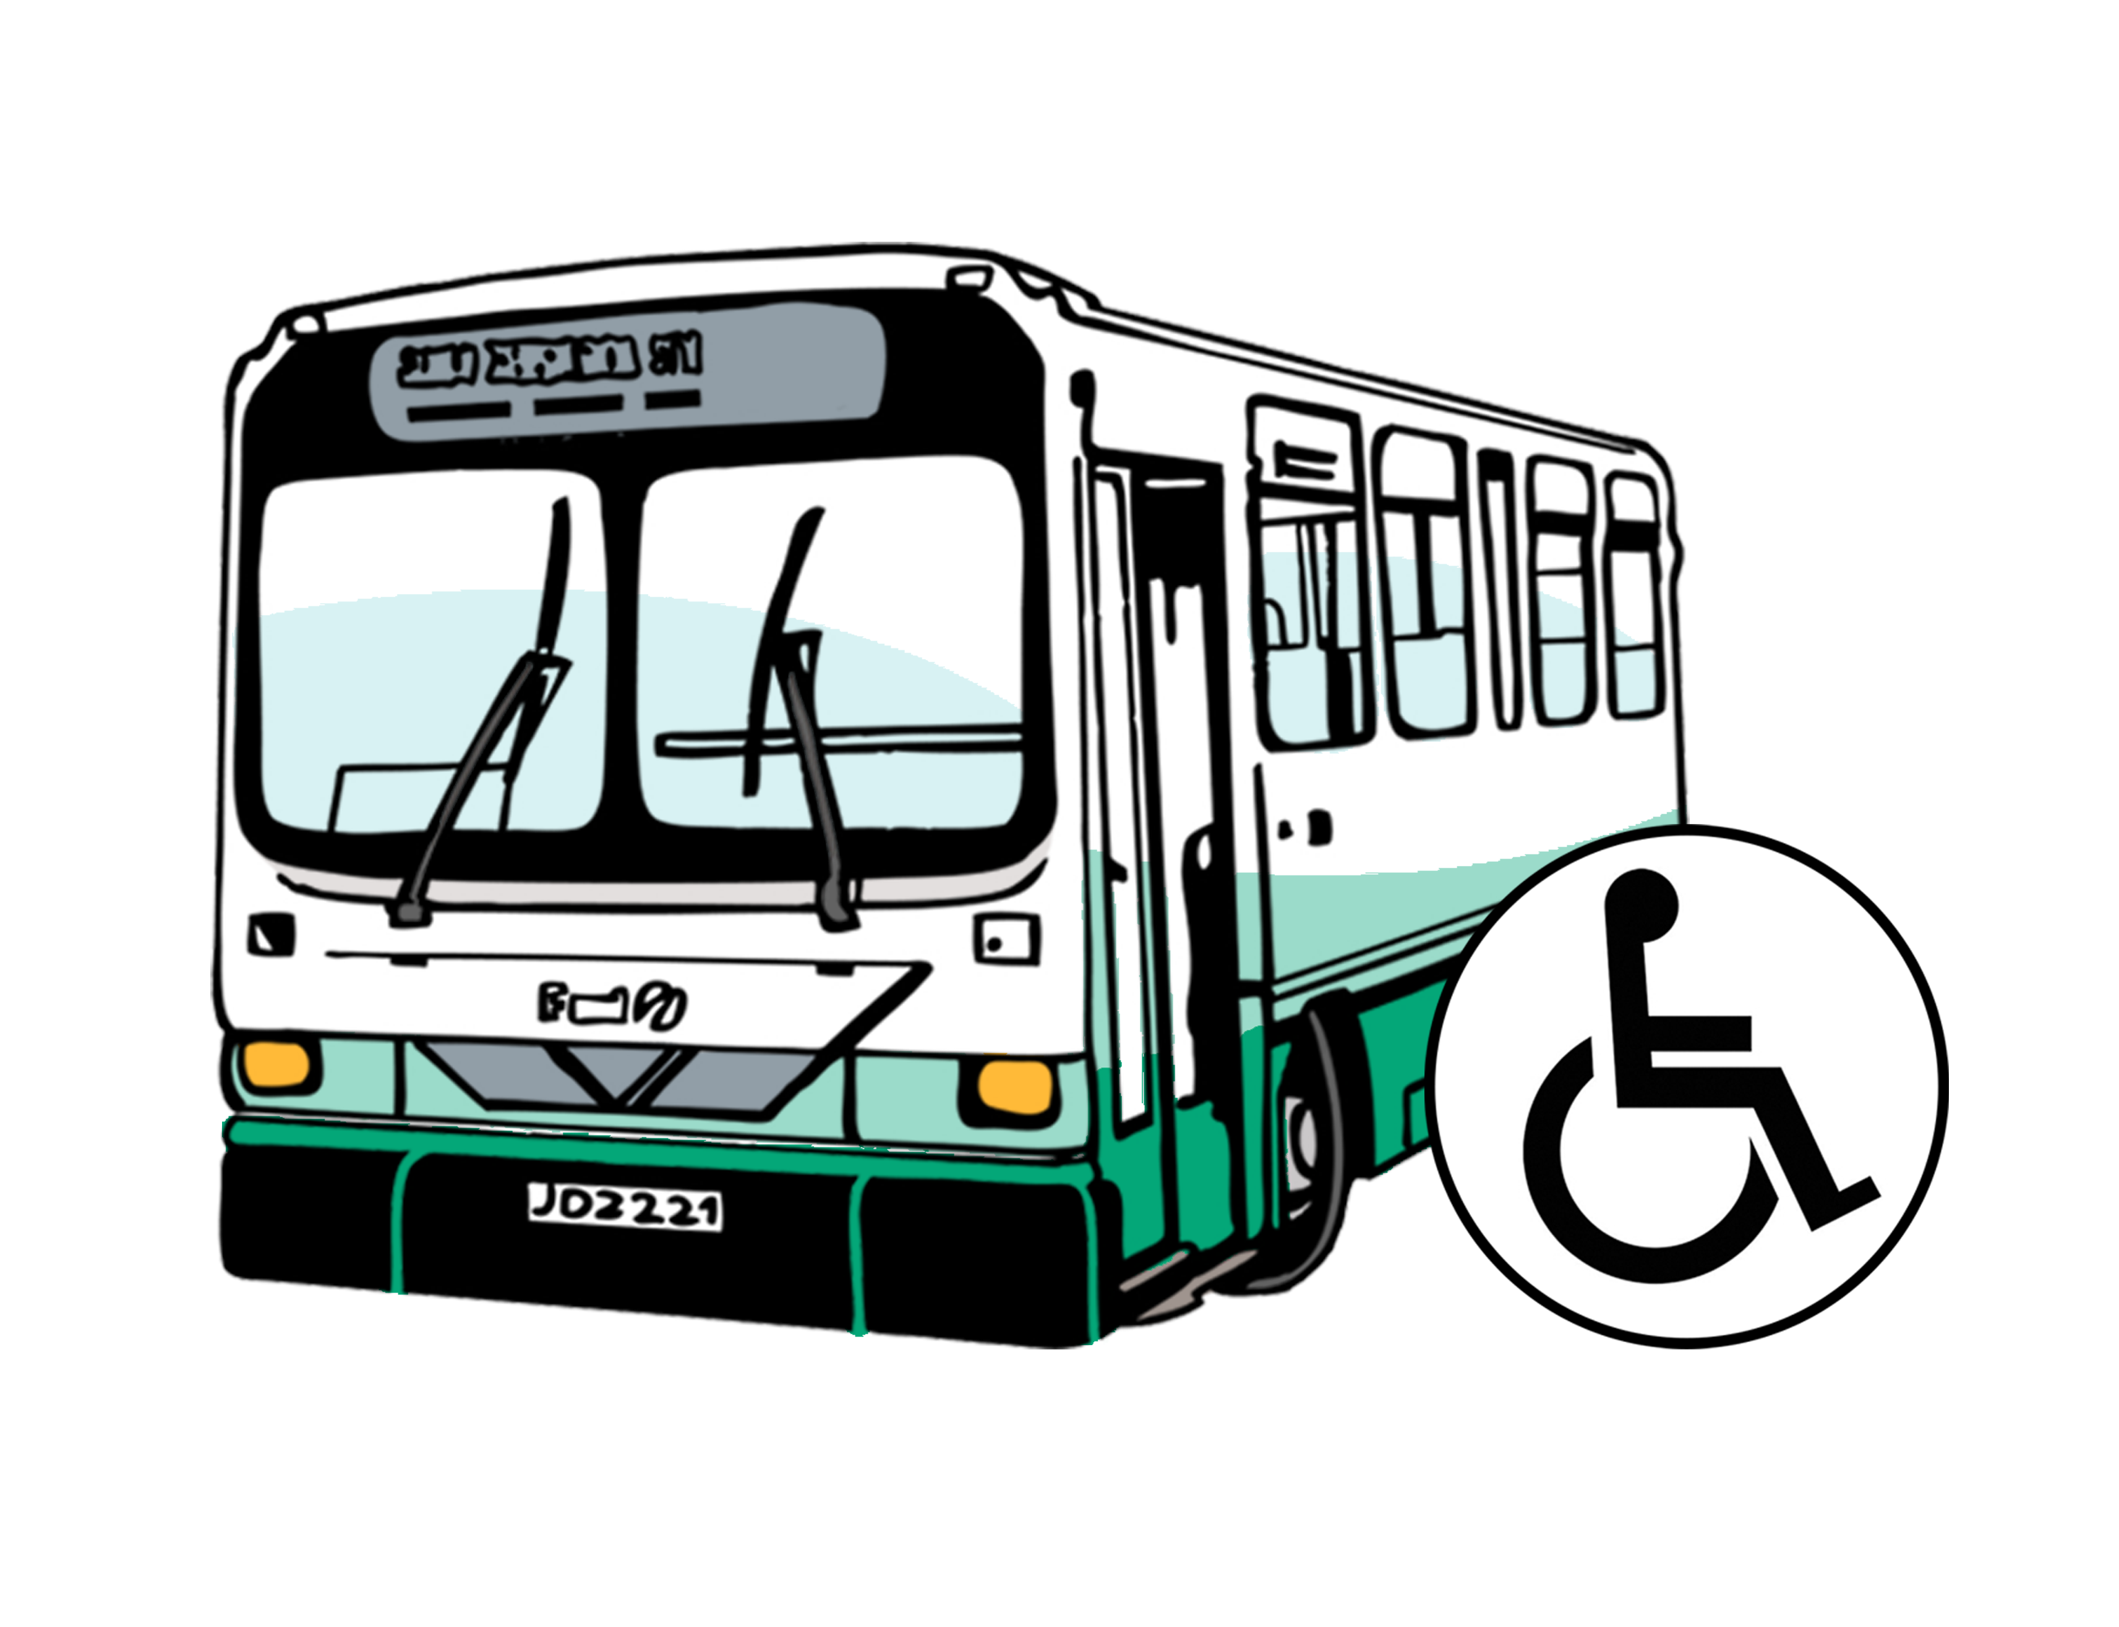
central government which
means the government for all
of Aotearoa New Zealand
- local government like public transport authorities.

Public transport means:
buses
trains
ferries.

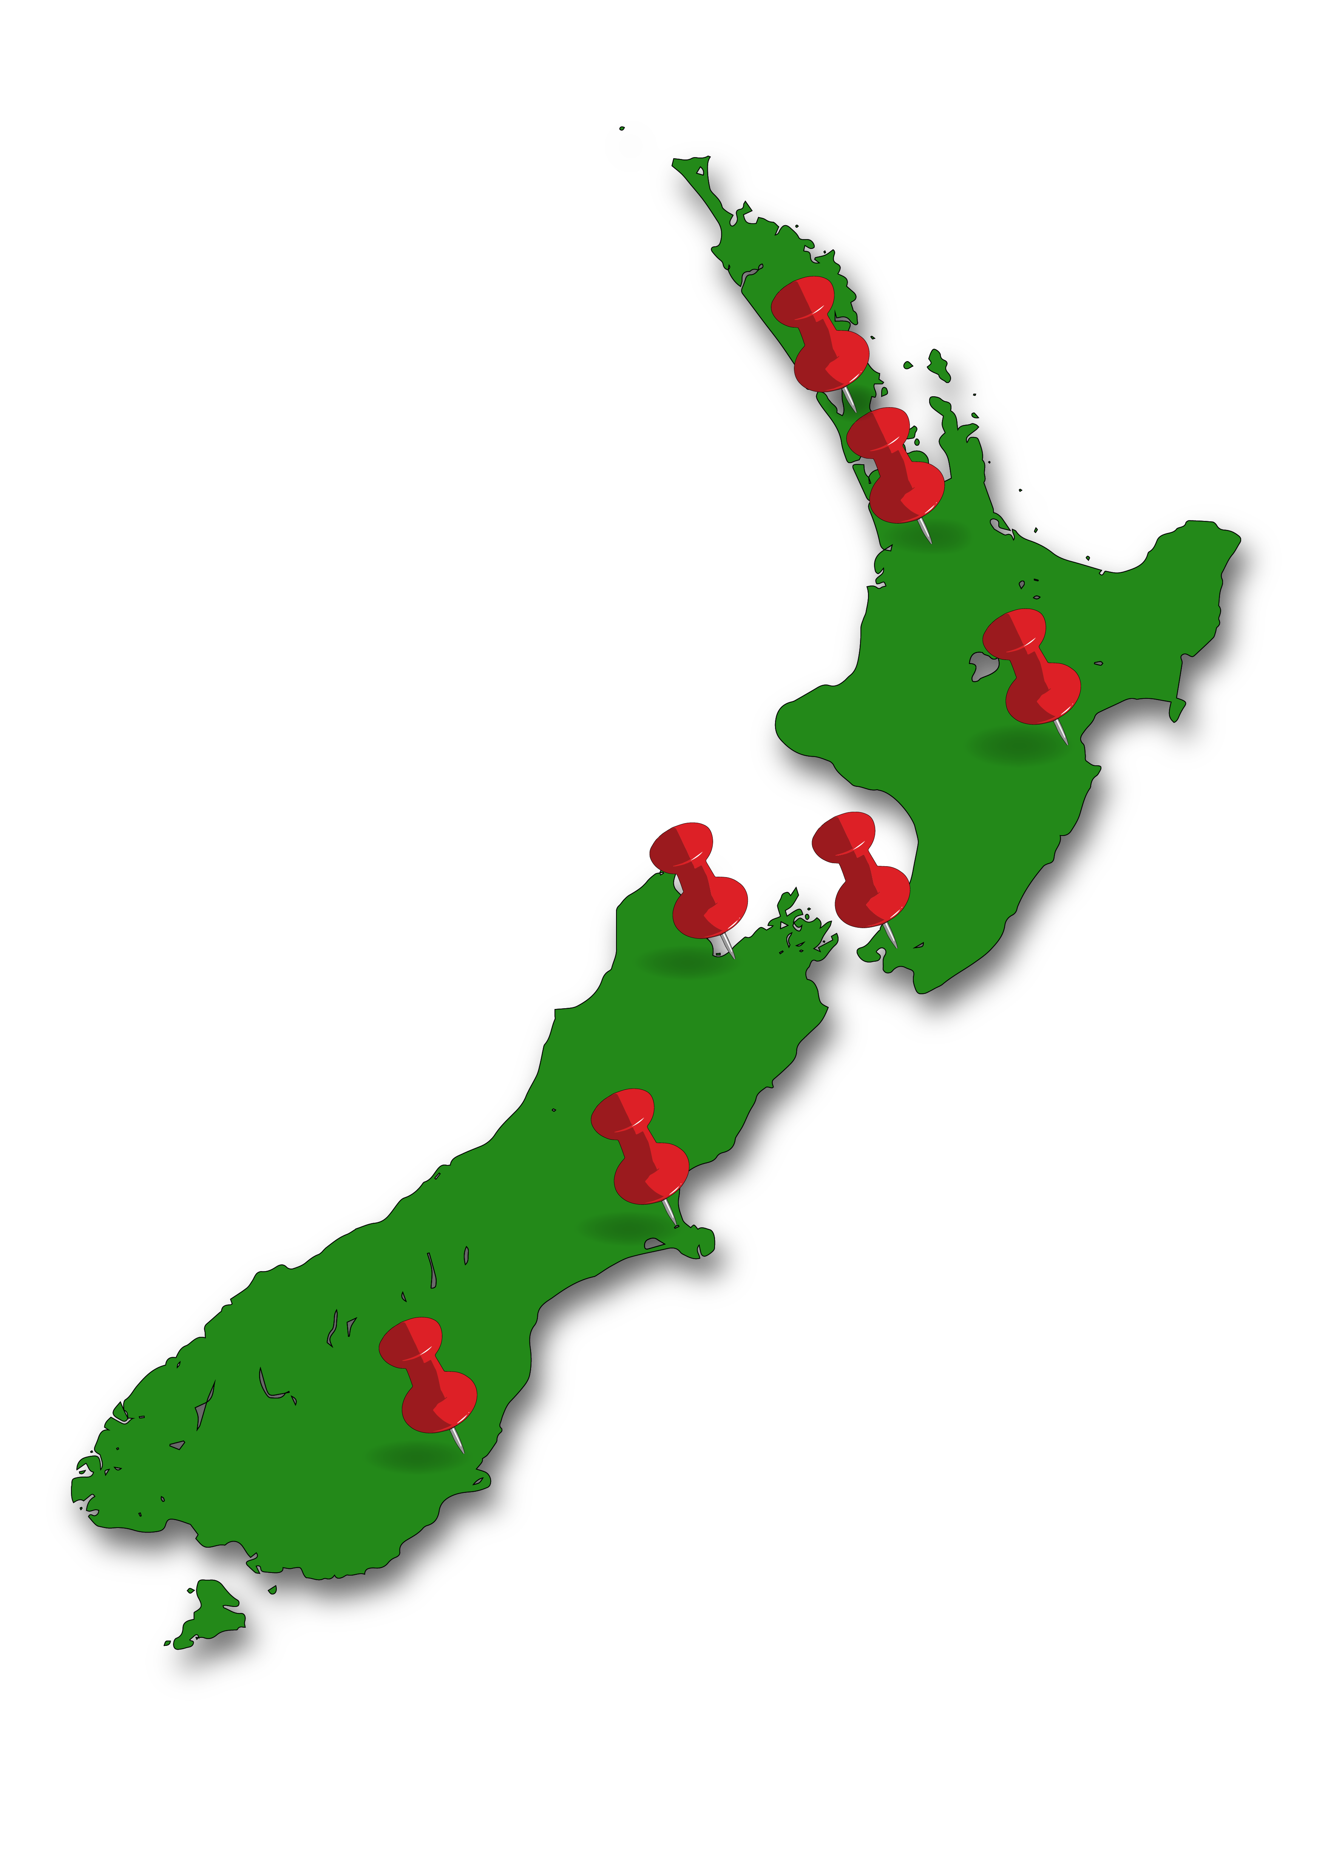
Public transport authorities are in charge of public transport in their
part of the Aotearoa New Zealand.


For example:
Auckland Transport is the public transport authority in Auckland
Greater Wellington Regional Council is the public transport authority in Wellington.

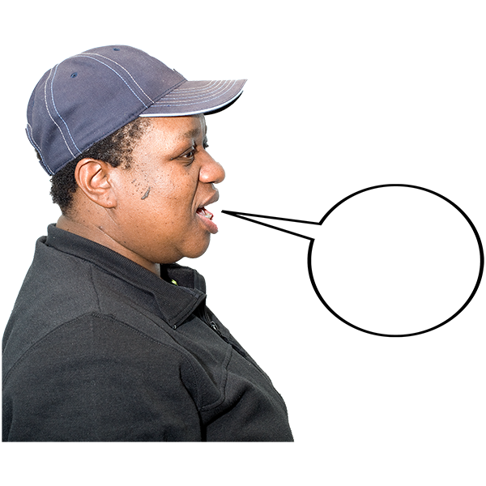
This document includes quotes which are words people have said.

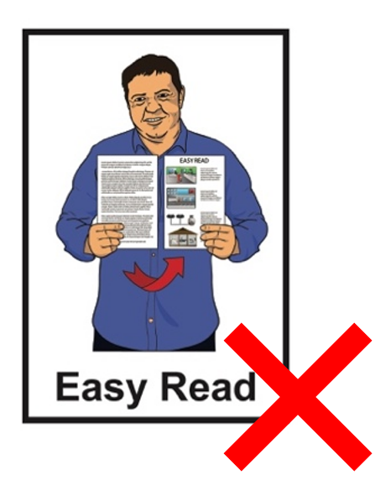
The quotes are:
not in Easy Read
in a green box.

About Total Mobility

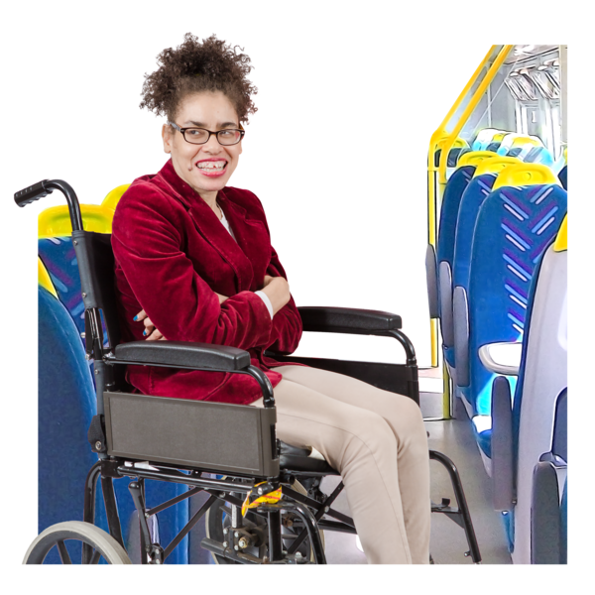
Using public transport:
makes it easier for people to:
- go to work

- study / go to school
supports a person to have a better life.

Total Mobility makes sure disabled people get the same benefits / good things from the transport system as everyone else.

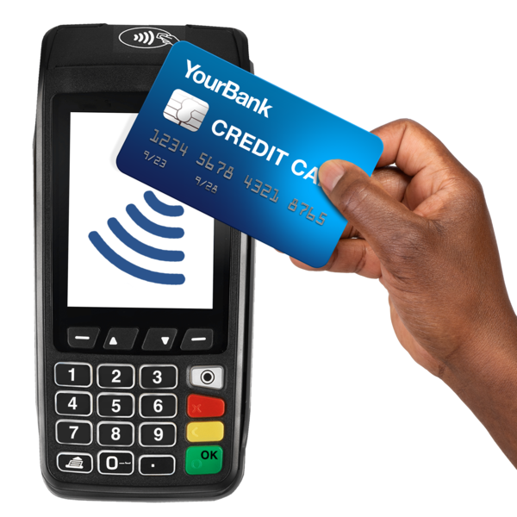
At the moment for every 1 dollar a taxi trip costs the:
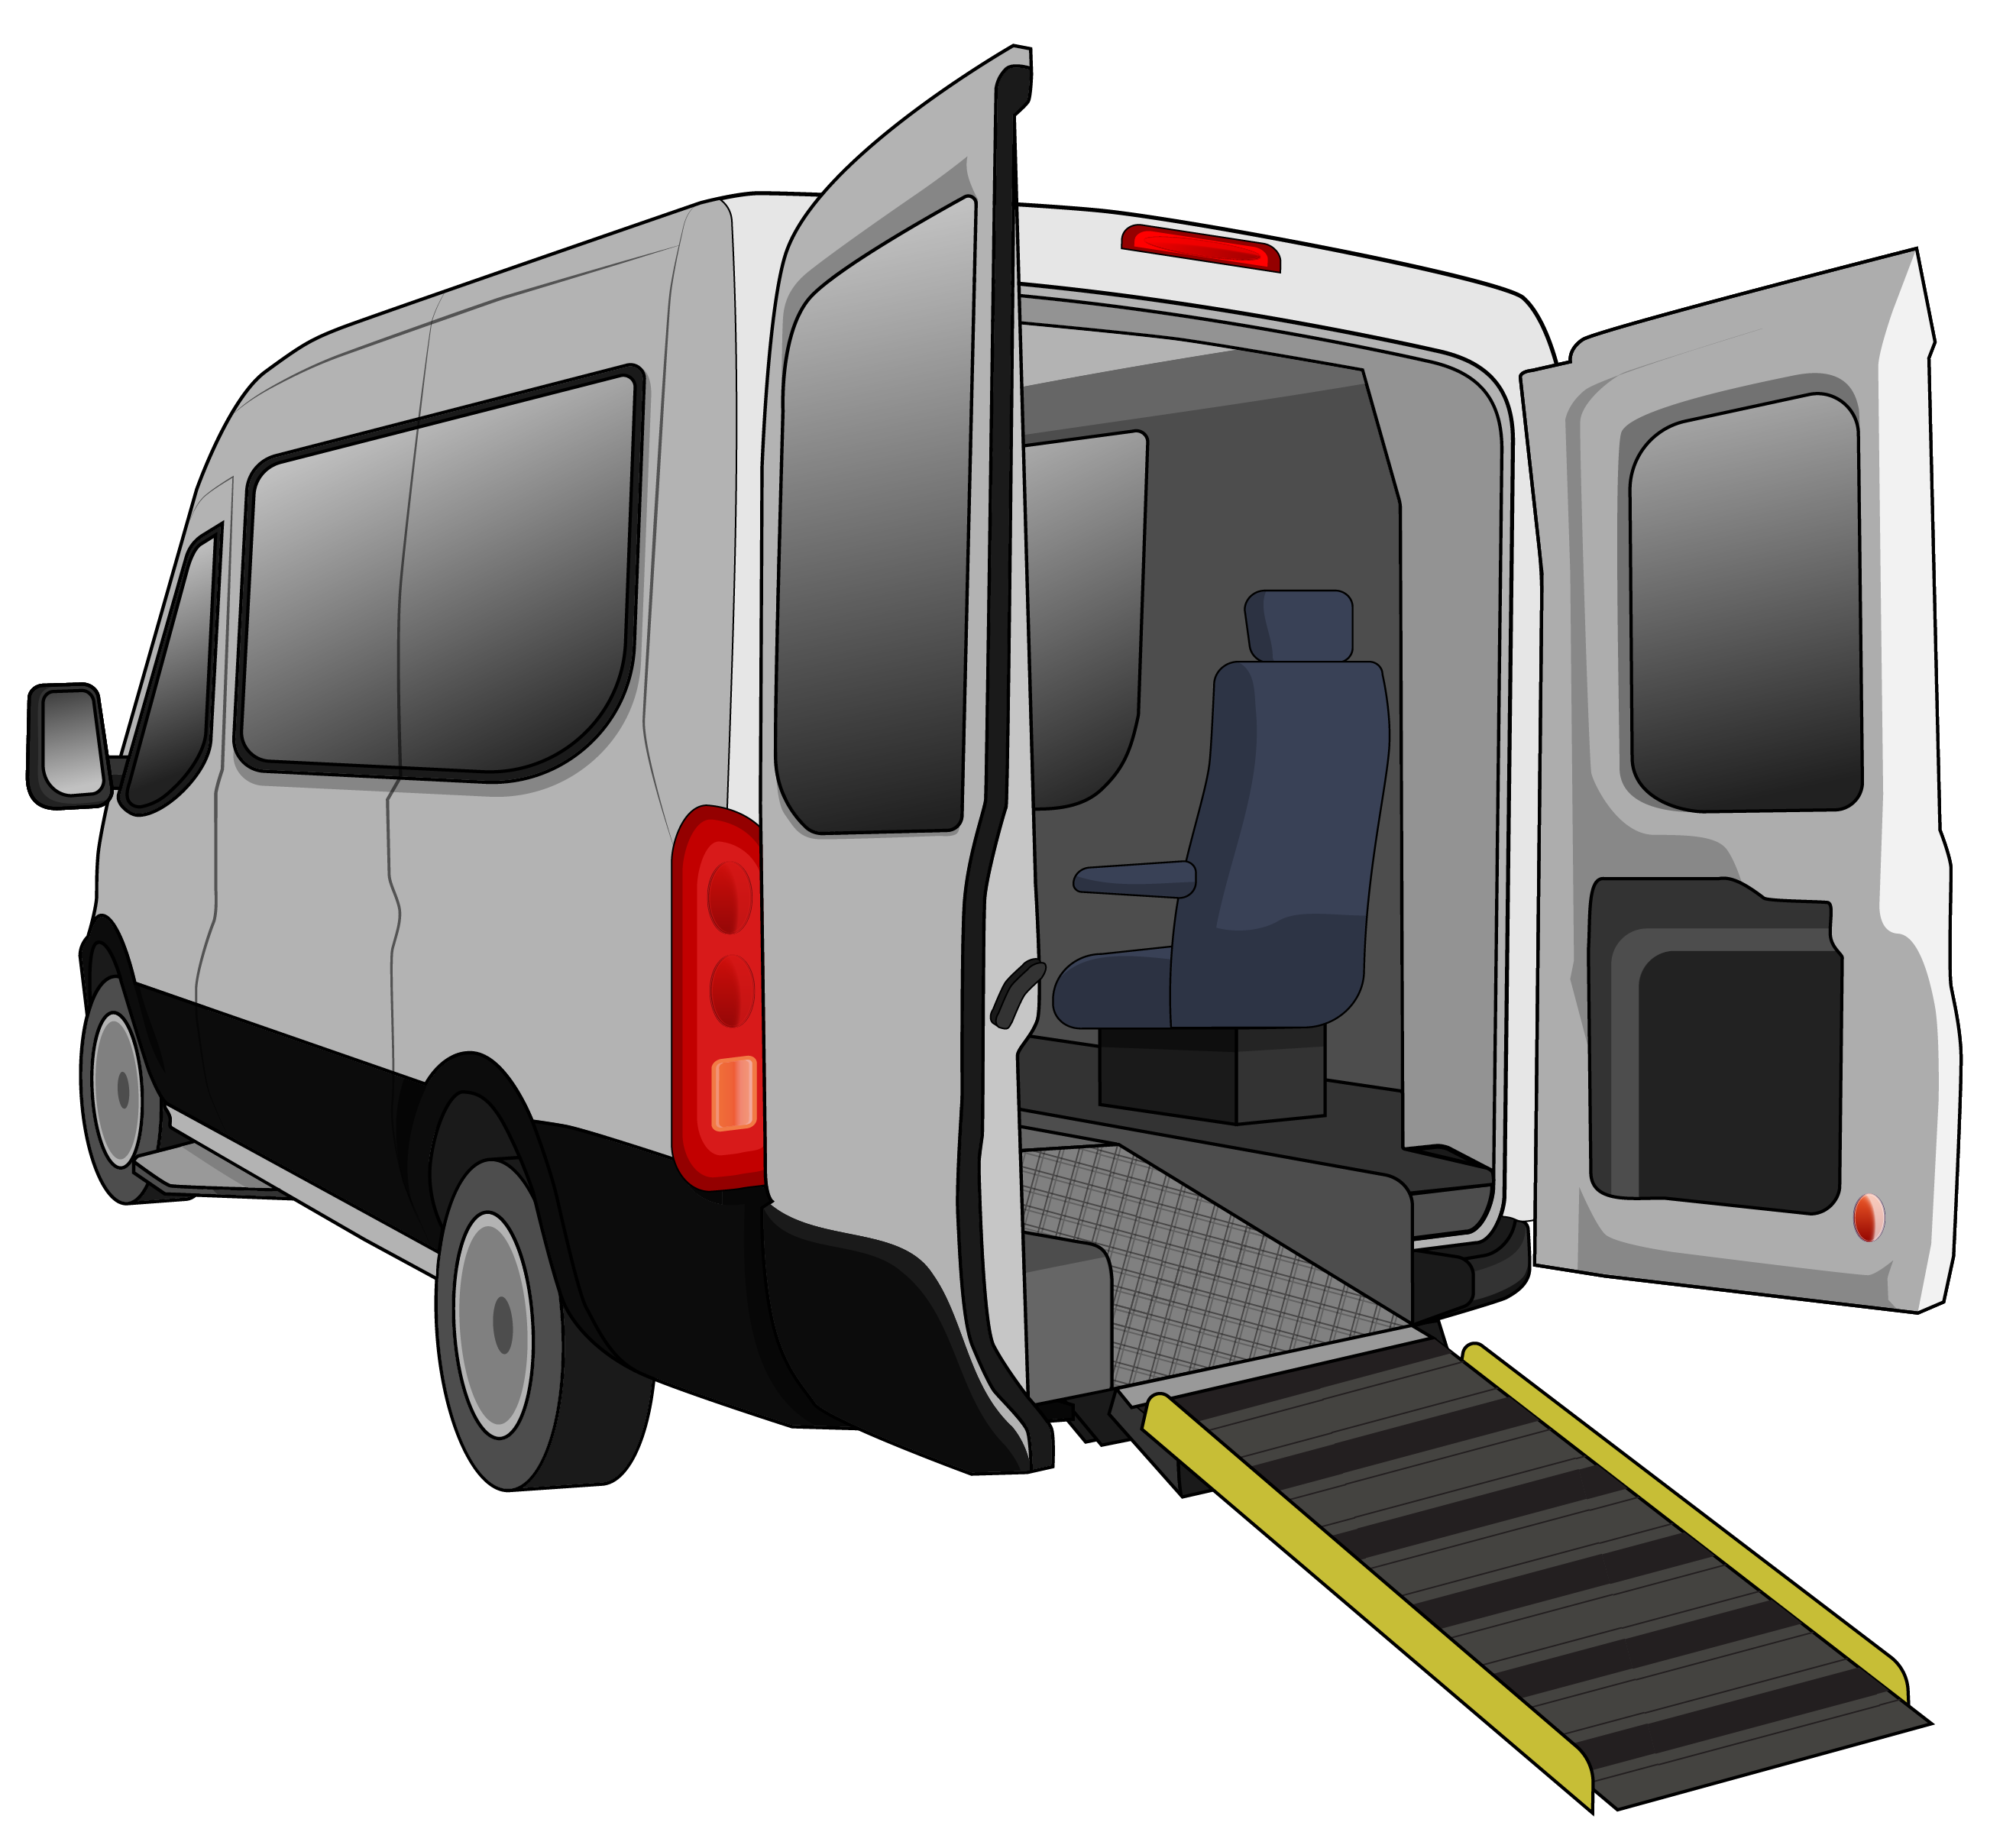
Government pays
75 cents
Total Mobility user pays
25 cents.

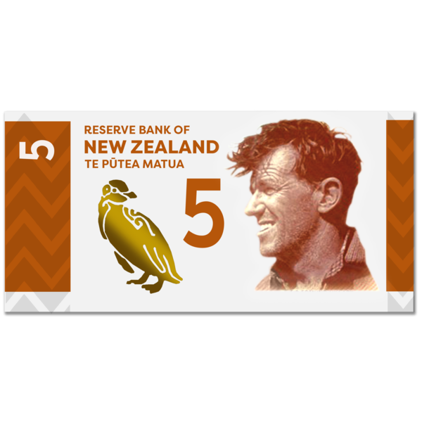
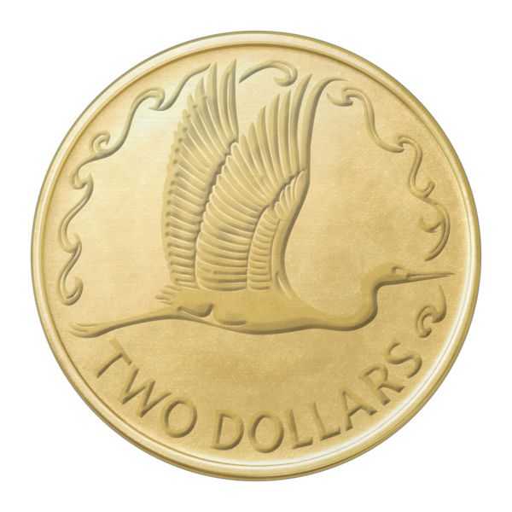
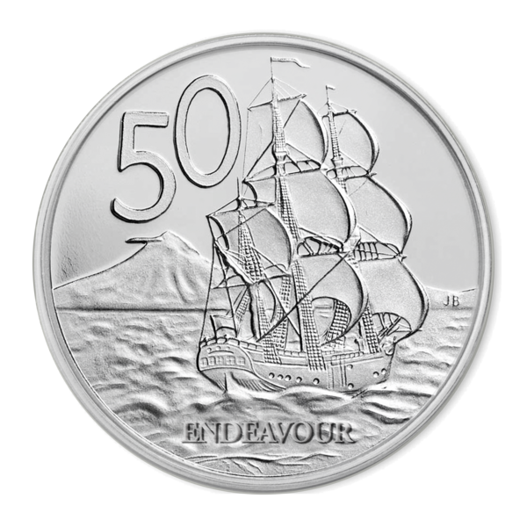
For example for a taxi trip that costs 10 dollars the:
Government would pay
7 dollars and 50 cents
Total Mobility user would pay
2 dollars and 50 cents.

Total Mobility fares are partly paid by:
the Government

the National Land Transport Fund
local councils.

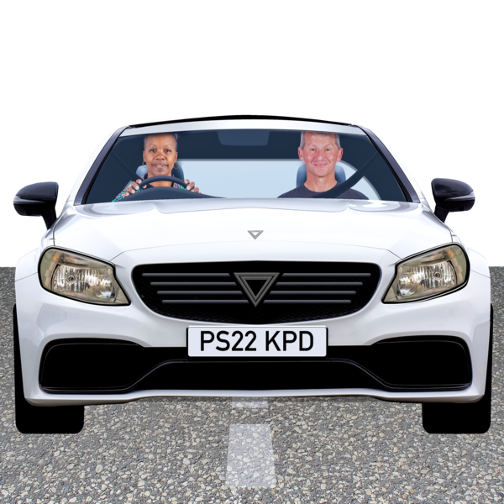
The National Land Transport Fund is the money that is used to take
care of things like:
roads
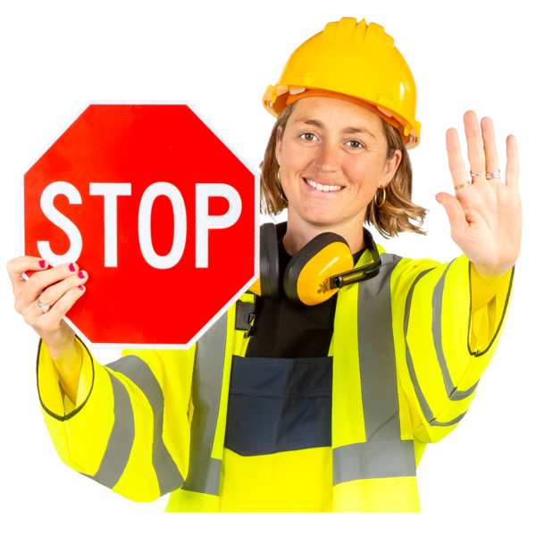
public transport
road safety.

The money for the National Land Transport Fund comes from things like:

road tolls / fees

car registrations which is money paid to use a car each year
taxes / money paid to the Government from sales of fuel.

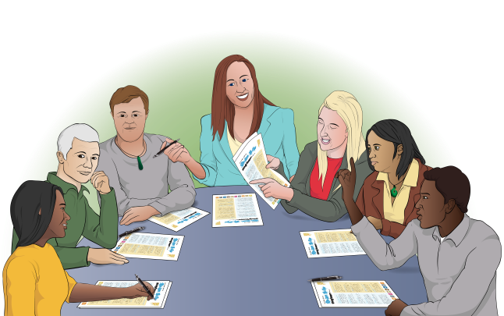
Here a council means the people who make choices about how to run a town / city.

Total Mobility review
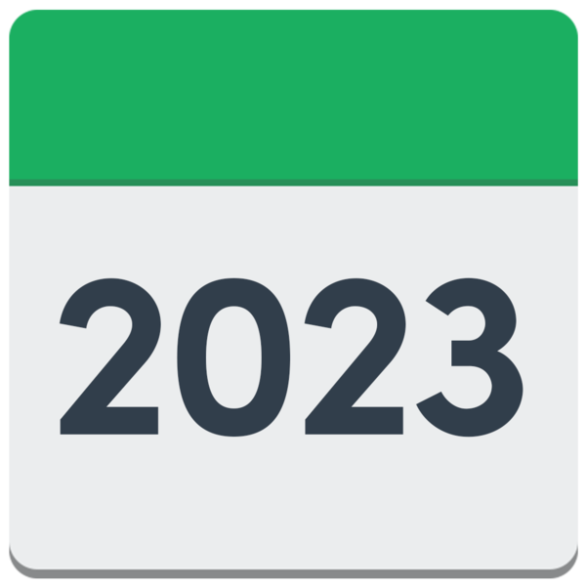

The Ministry of Transport started a review of Total Mobility in 2023.

Here a review means:
checking something carefully
finding out if any changes need to be made.

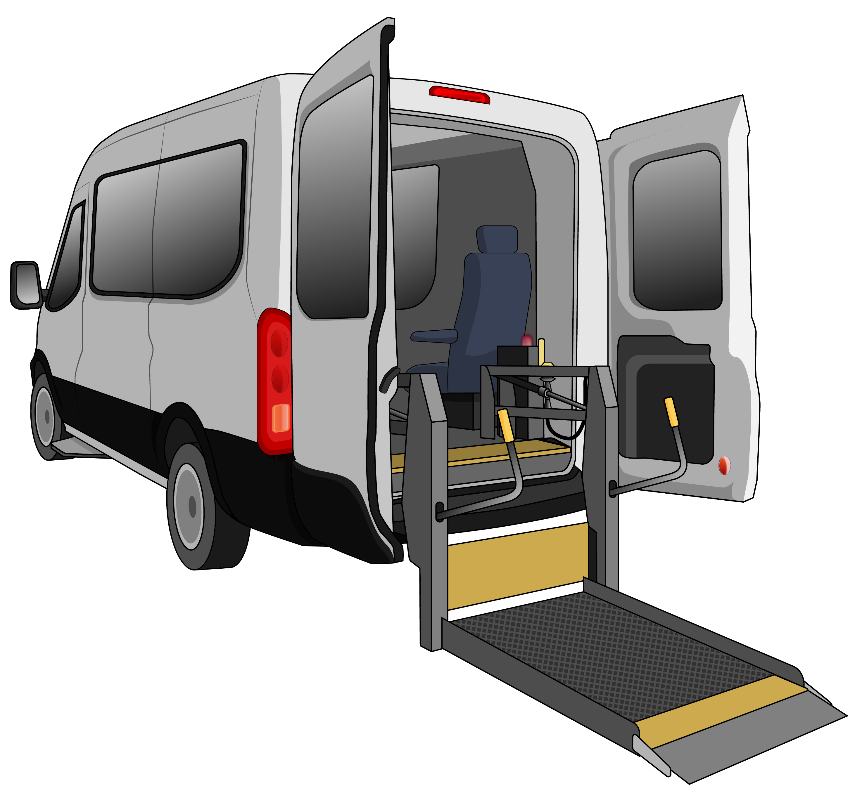
The review looks at:
what Total Mobility is for
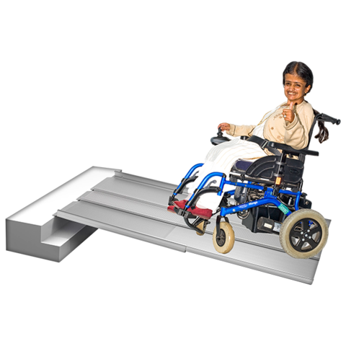
how to make Total Mobility easier for disabled people to:
- access
- use.
The review also looks at:
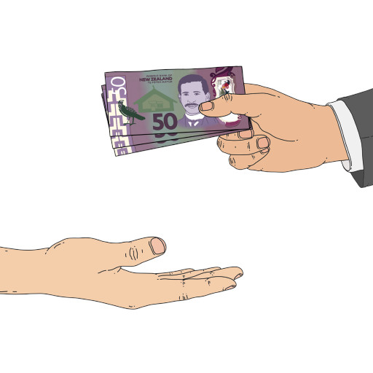
how to improve how Total Mobility works
how to fund Total Mobility in a way that it will keep going.


We found out that Total Mobility is very important for disabled people.

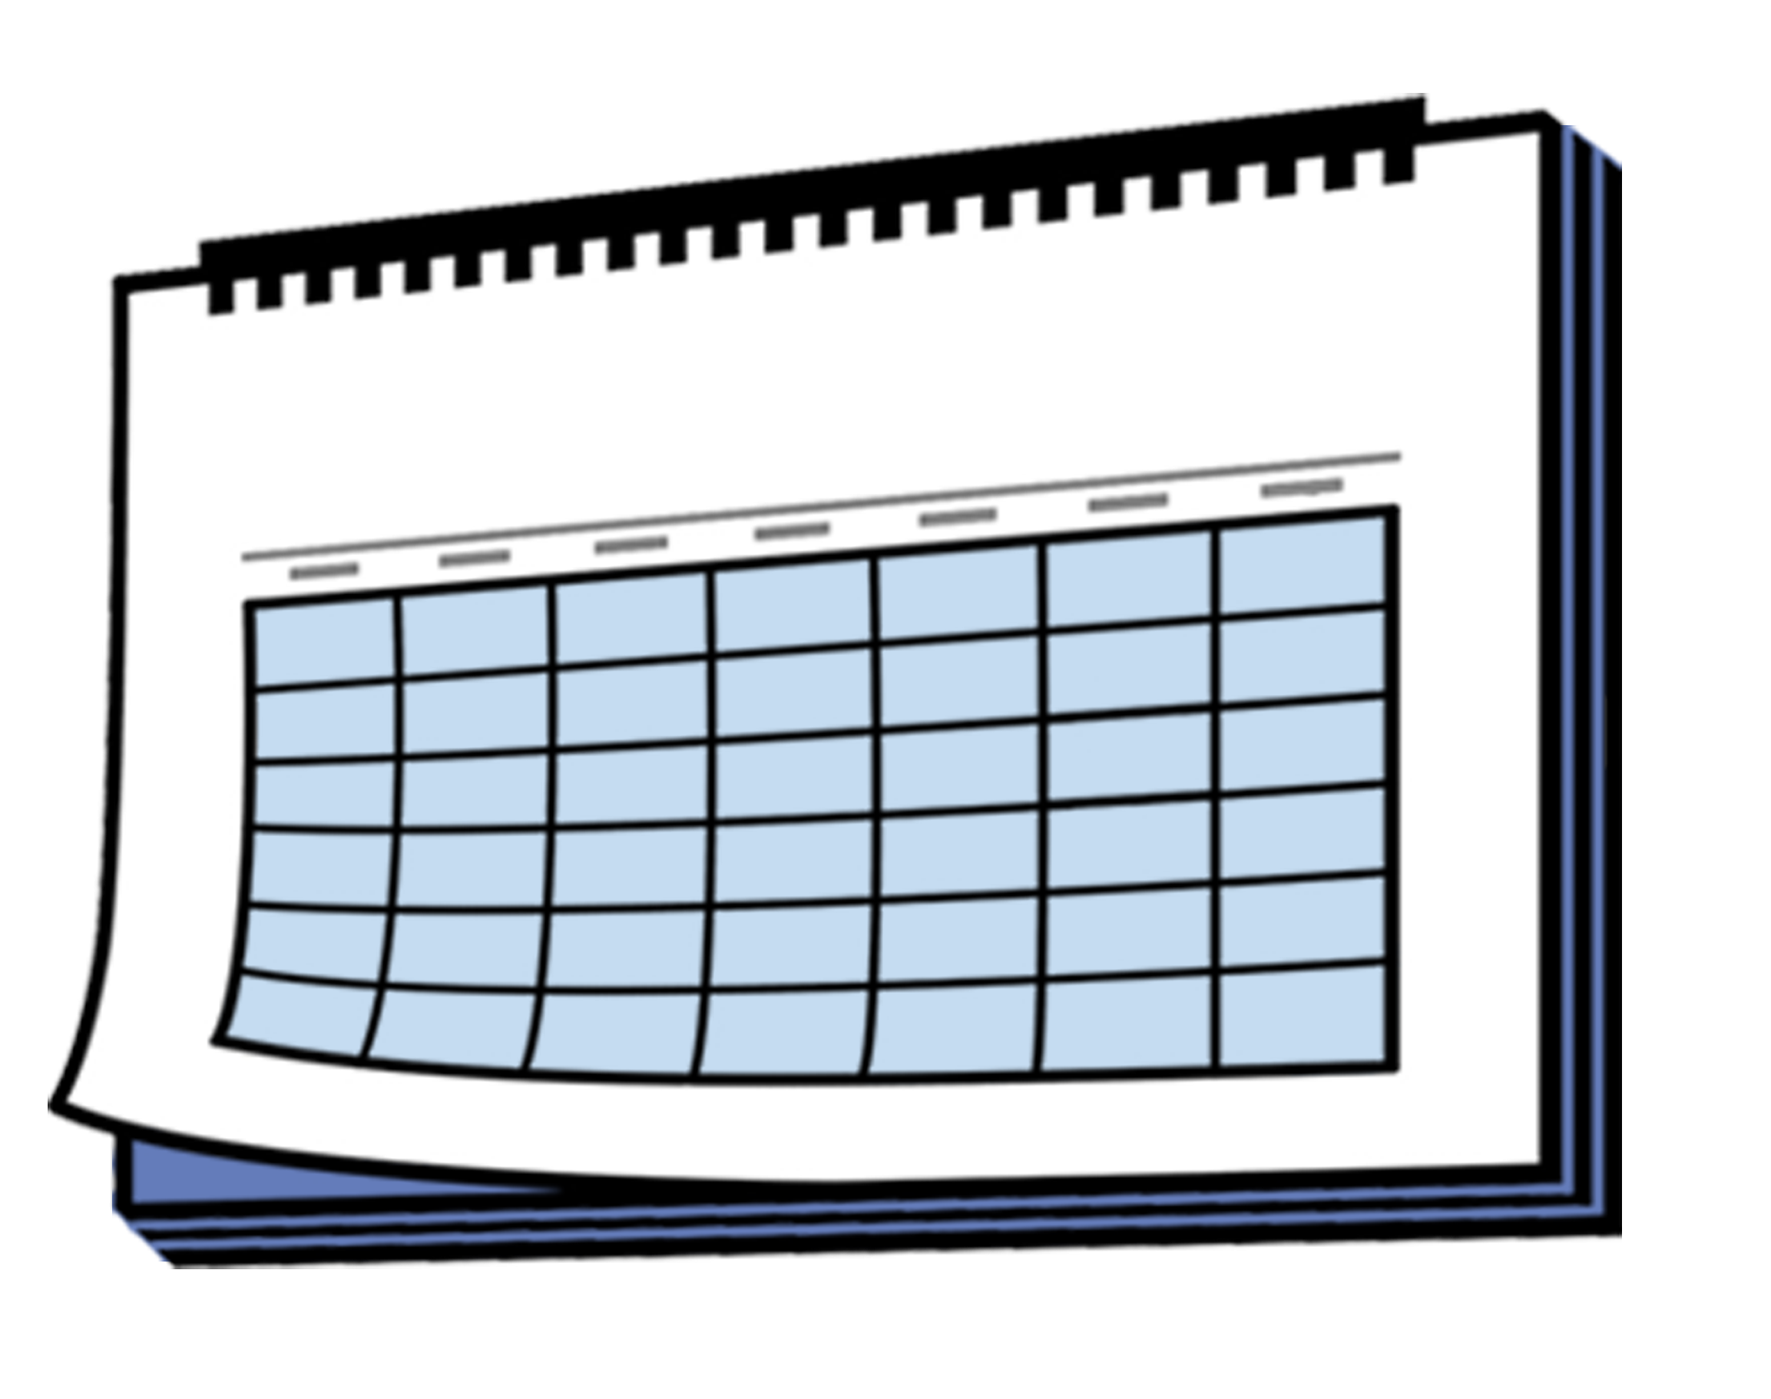
We also found ways to make improvements that will last for:
a little while

and
a long time.

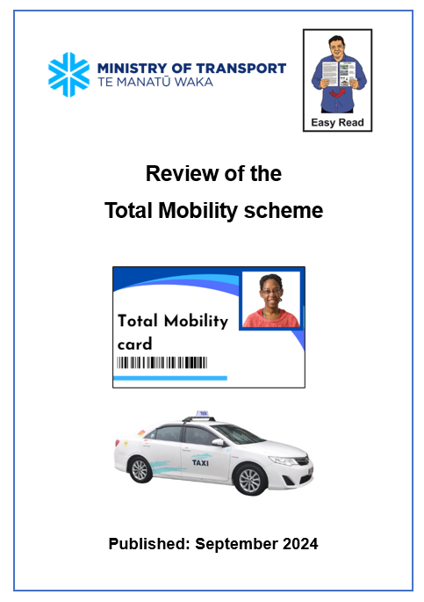
You can read the Easy Read guidelines for the Review of the Total Mobility scheme here:

https://tinyurl.com/ytwvsy7v

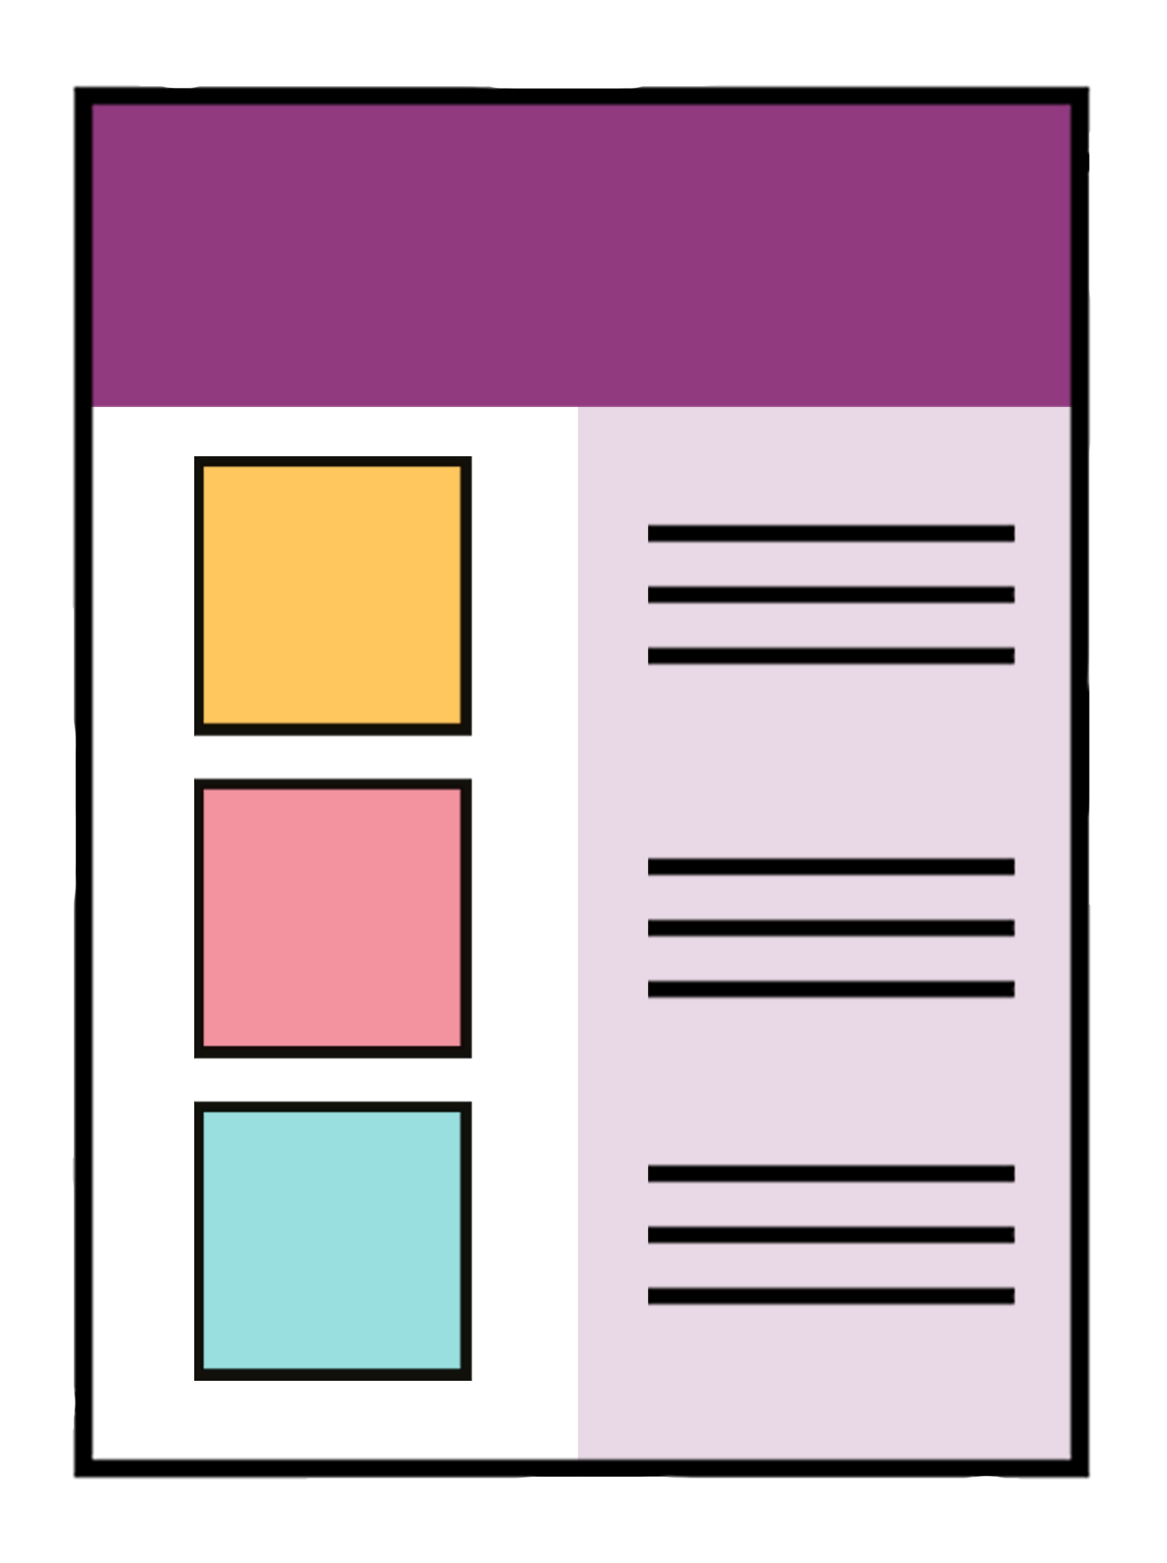
This Easy Read has 6 proposals for changes to Total Mobility that you can give your feedback on.

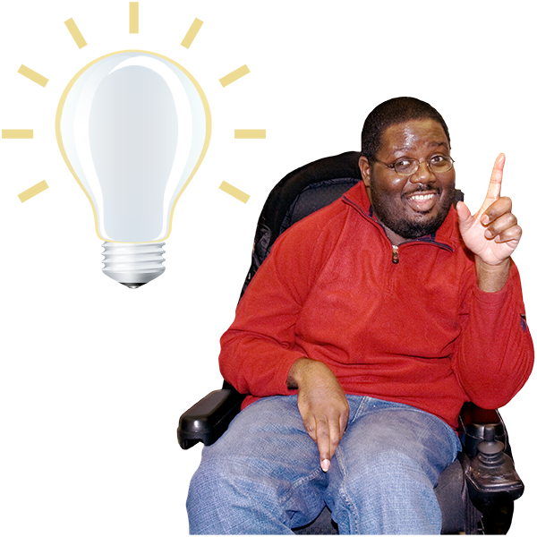
Here a proposal means a:
kind of idea
thing that might be good to do.

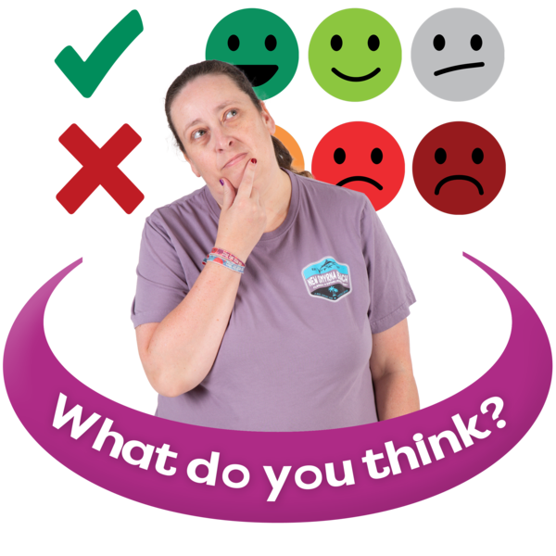
Feedback means saying what you think about something.

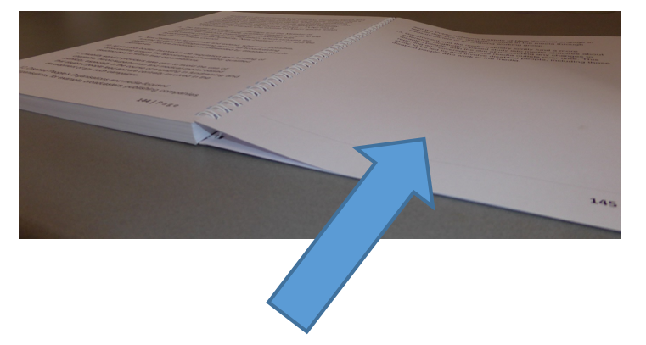
Information on how to give your feedback is on pages 33 to 36.


After we get the feedback we will:
give the Government our
advice / what we think
finish the review.

Changes that have just happened

In 2024 – 2025 people did 3 million trips using Total Mobility.

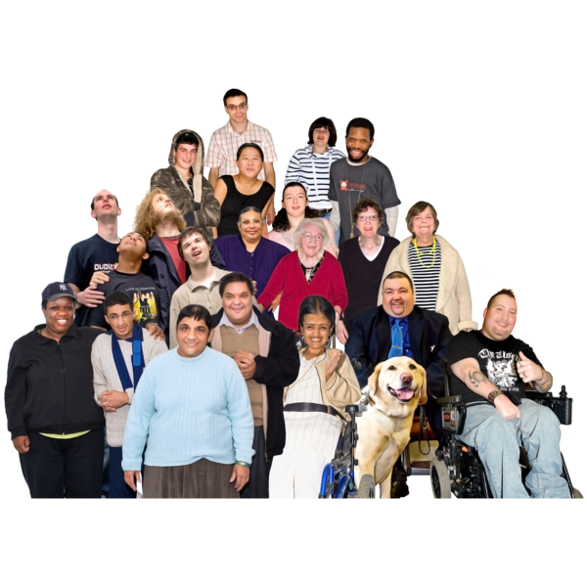
By 2024 there were 1 hundred and 20 thousand people using Total Mobility.


While it is good more people are using Total Mobility it means the costs to run it are getting bigger.

We think the costs have got bigger because in 2022 the Government added more funding with Community Connect.

Community Connect cut fares in half for Total Mobility users.

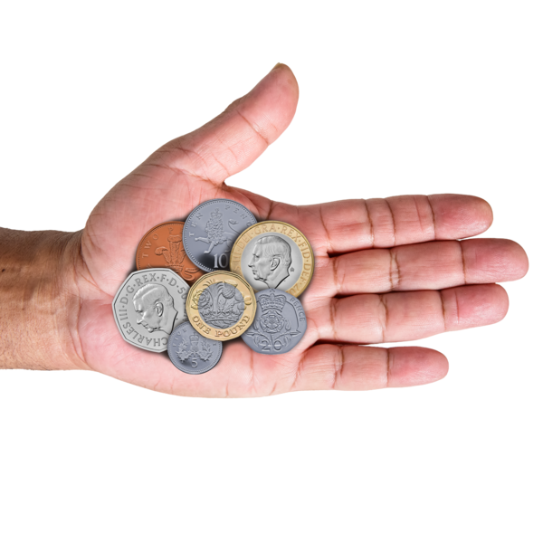
Since this change users pay only 25 cents for every 1 dollar of a fare up to a fare cap.

A fare cap is the highest amount of money the Total Mobility scheme
will pay part of for each trip.

For example if the fare cap is
25 dollars the Government will pay part of every dollar for the first 25 dollars.

If the trip costs more than
25 dollars the Total Mobility user will have to pay the full cost of every dollar over 25 dollars.

Each part of Aotearoa New Zealand has a different fare cap.
Costs for Total Mobility will keep getting bigger because:
more people will use the scheme
of changes to the price of
fuel / petrol
people are doing longer trips.

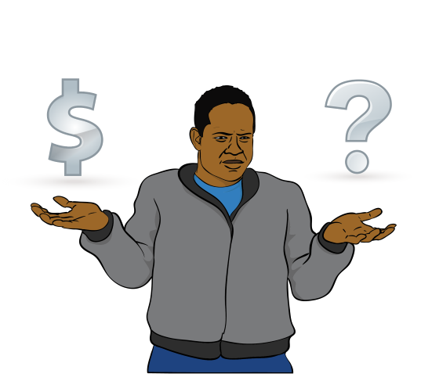
Total Mobility is at risk of not being funded in the future if costs keep getting bigger.


The future is a time that is yet to happen.

What will change from July 2026

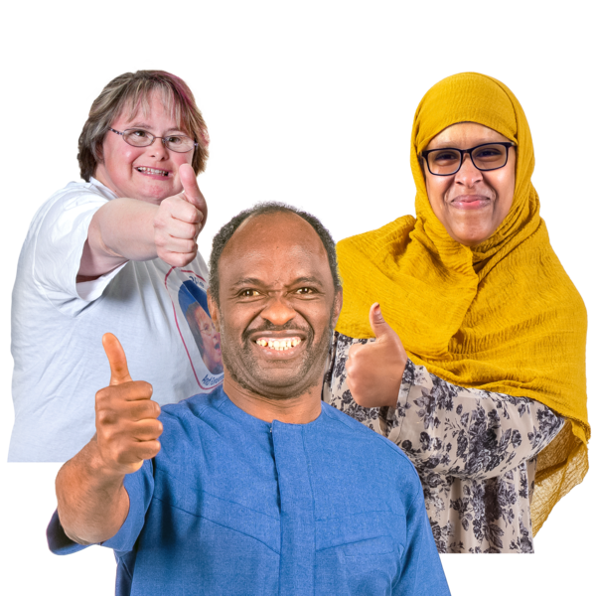
The Government needs to keep Total Mobility:
fair for everyone
easy to fund.

Changes will be made to Total Mobility from 1 July 2026.

From 1 July 2026 for every 1 dollar a taxi trip costs the:
Government will pay
65 cents
Total Mobility user will pay
35 cents.


For example for a taxi trip that will cost 10 dollars the:
Government will pay
6 dollars and 50 cents
Total Mobility user will pay
3 dollars and 50 cents.

$$
$
From 1 July 2026 the fare cap will be made lower around the country.


From 1 July 2026 the Government will give some money to local councils to:
cover some of their costs paying for Total Mobility
keep local councils in the Total Mobility scheme.

Proposals to make Total Mobility stronger

We want to make Total Mobility better for:
users
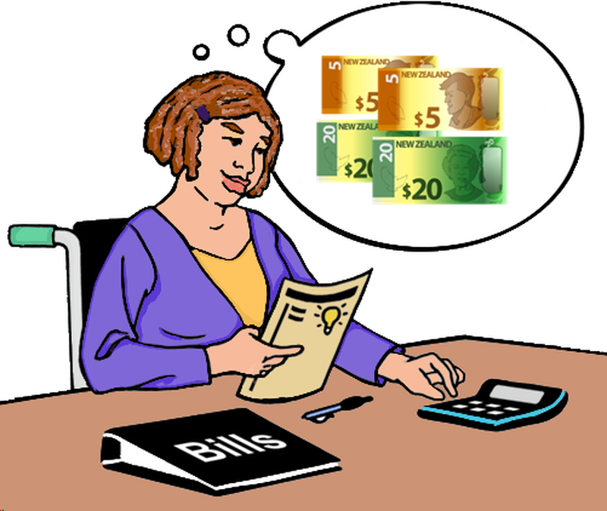
funders / people who give it money to run.

The 6 proposals we want your feedback on are on pages 22 to 32.



No decisions have been made about the proposals.

Proposal 1: Make a clear purpose statement for Total Mobility.

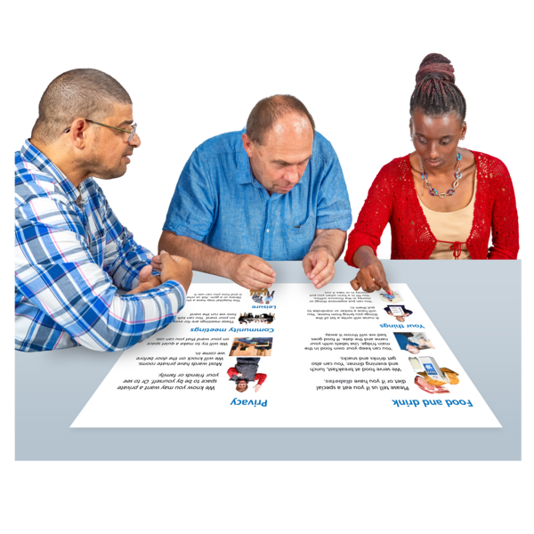
A purpose statement talks about what an organisation:
does
wants to do.

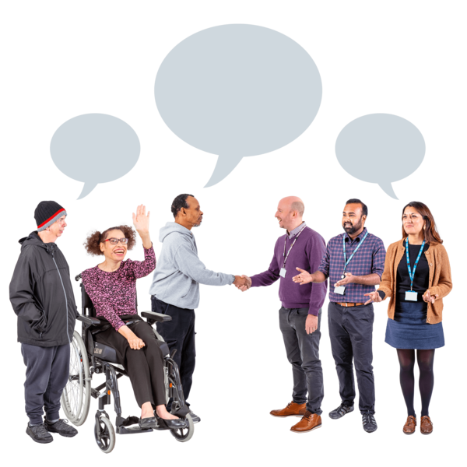
The purpose of Total Mobility is described in different ways by different organisations.

We suggest the purpose statement be:

“To provide subsidised mobility services to disabled people who are unable to access public transport because of an impairment, to
support them to live their lives.”
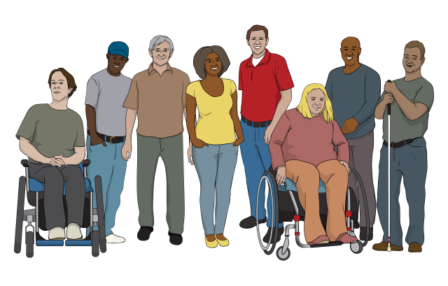
The proposed purpose statement means Total Mobility is for disabled people with an impairment that stops them from using public transport.

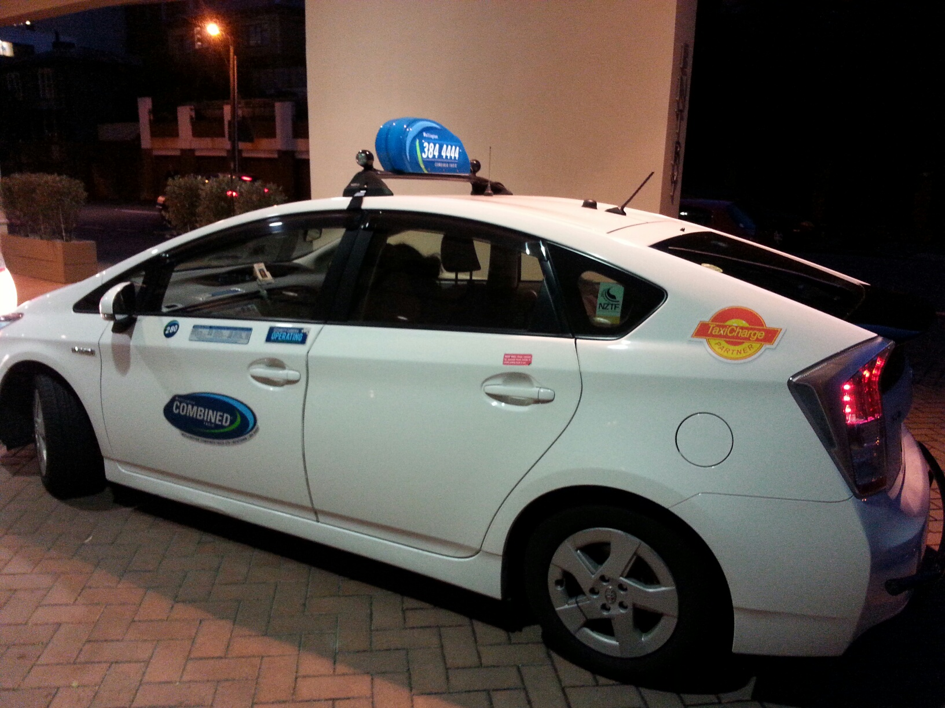
This means they will have cheaper taxi fares so they can live their lives.

Proposal 2: Make changes to assessments.
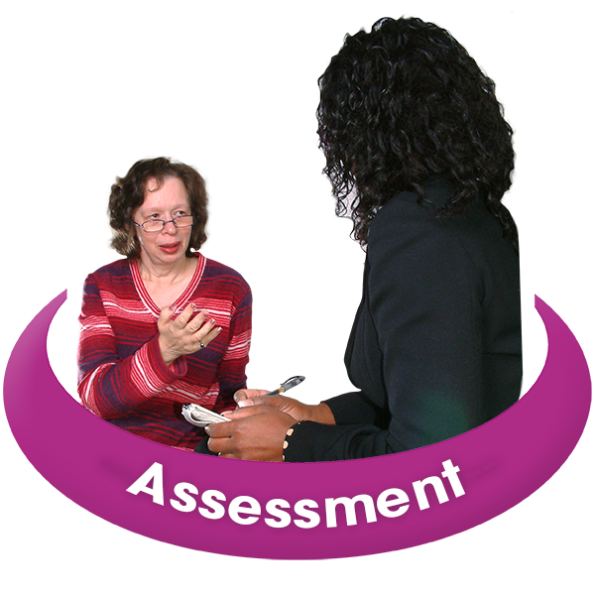
Here an assessment means talking about your disability to find out if you can use Total Mobility.

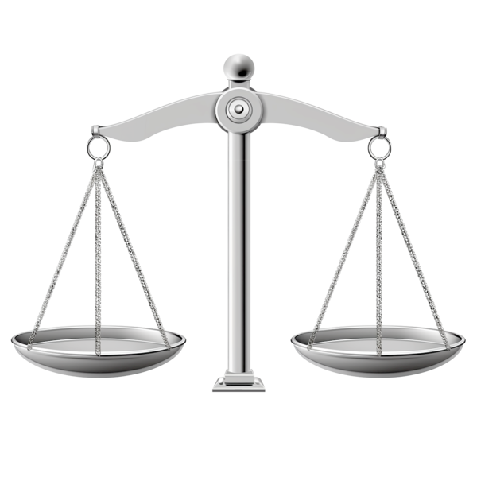
Part of this proposal includes making assessments:
fair

consistent / much the same for everyone.
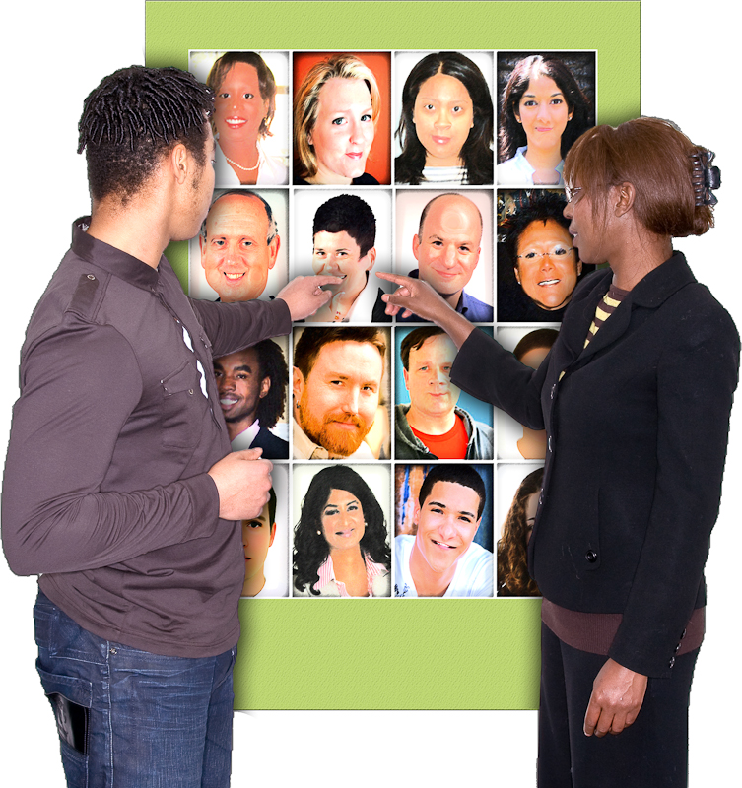
We are not changing who can use Total Mobility.

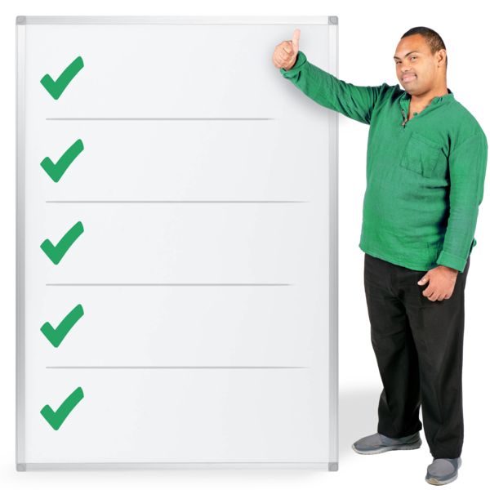
We want to make the assessment system stronger.


Part of this proposal includes Total Mobility users showing proof of their impairment.

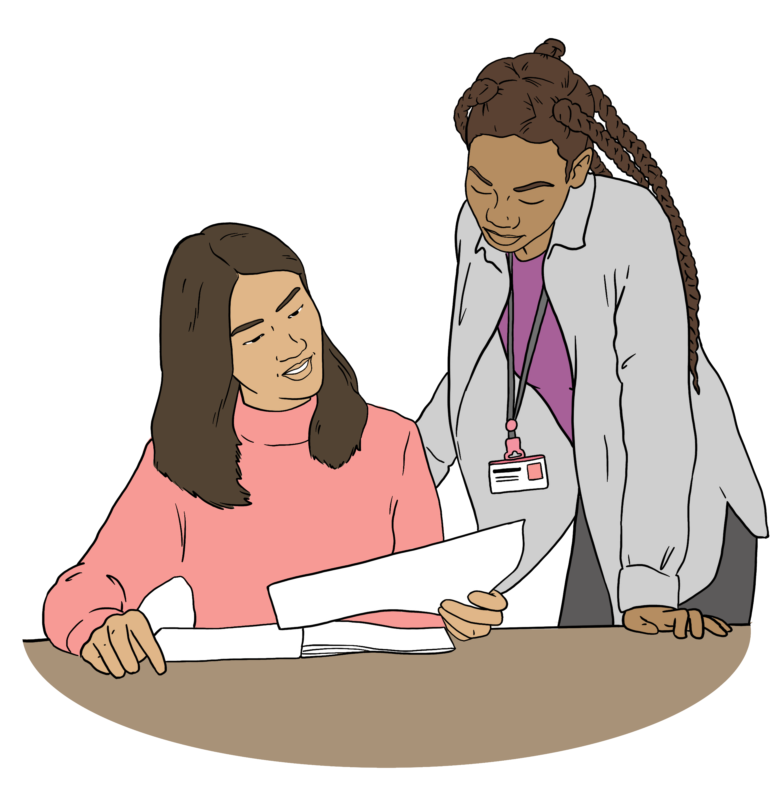
At the moment there is no need to show documents as part of the assessment.

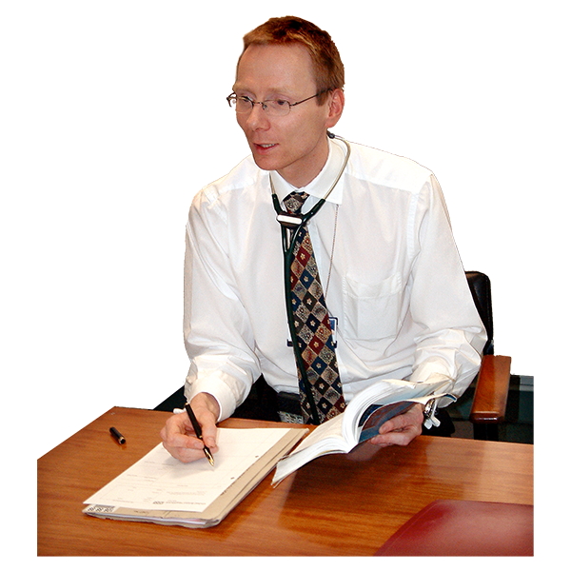
We are thinking about if we should ask people applying for Total Mobility to show us proof of why they cannot use public transport like a:
medical certificate
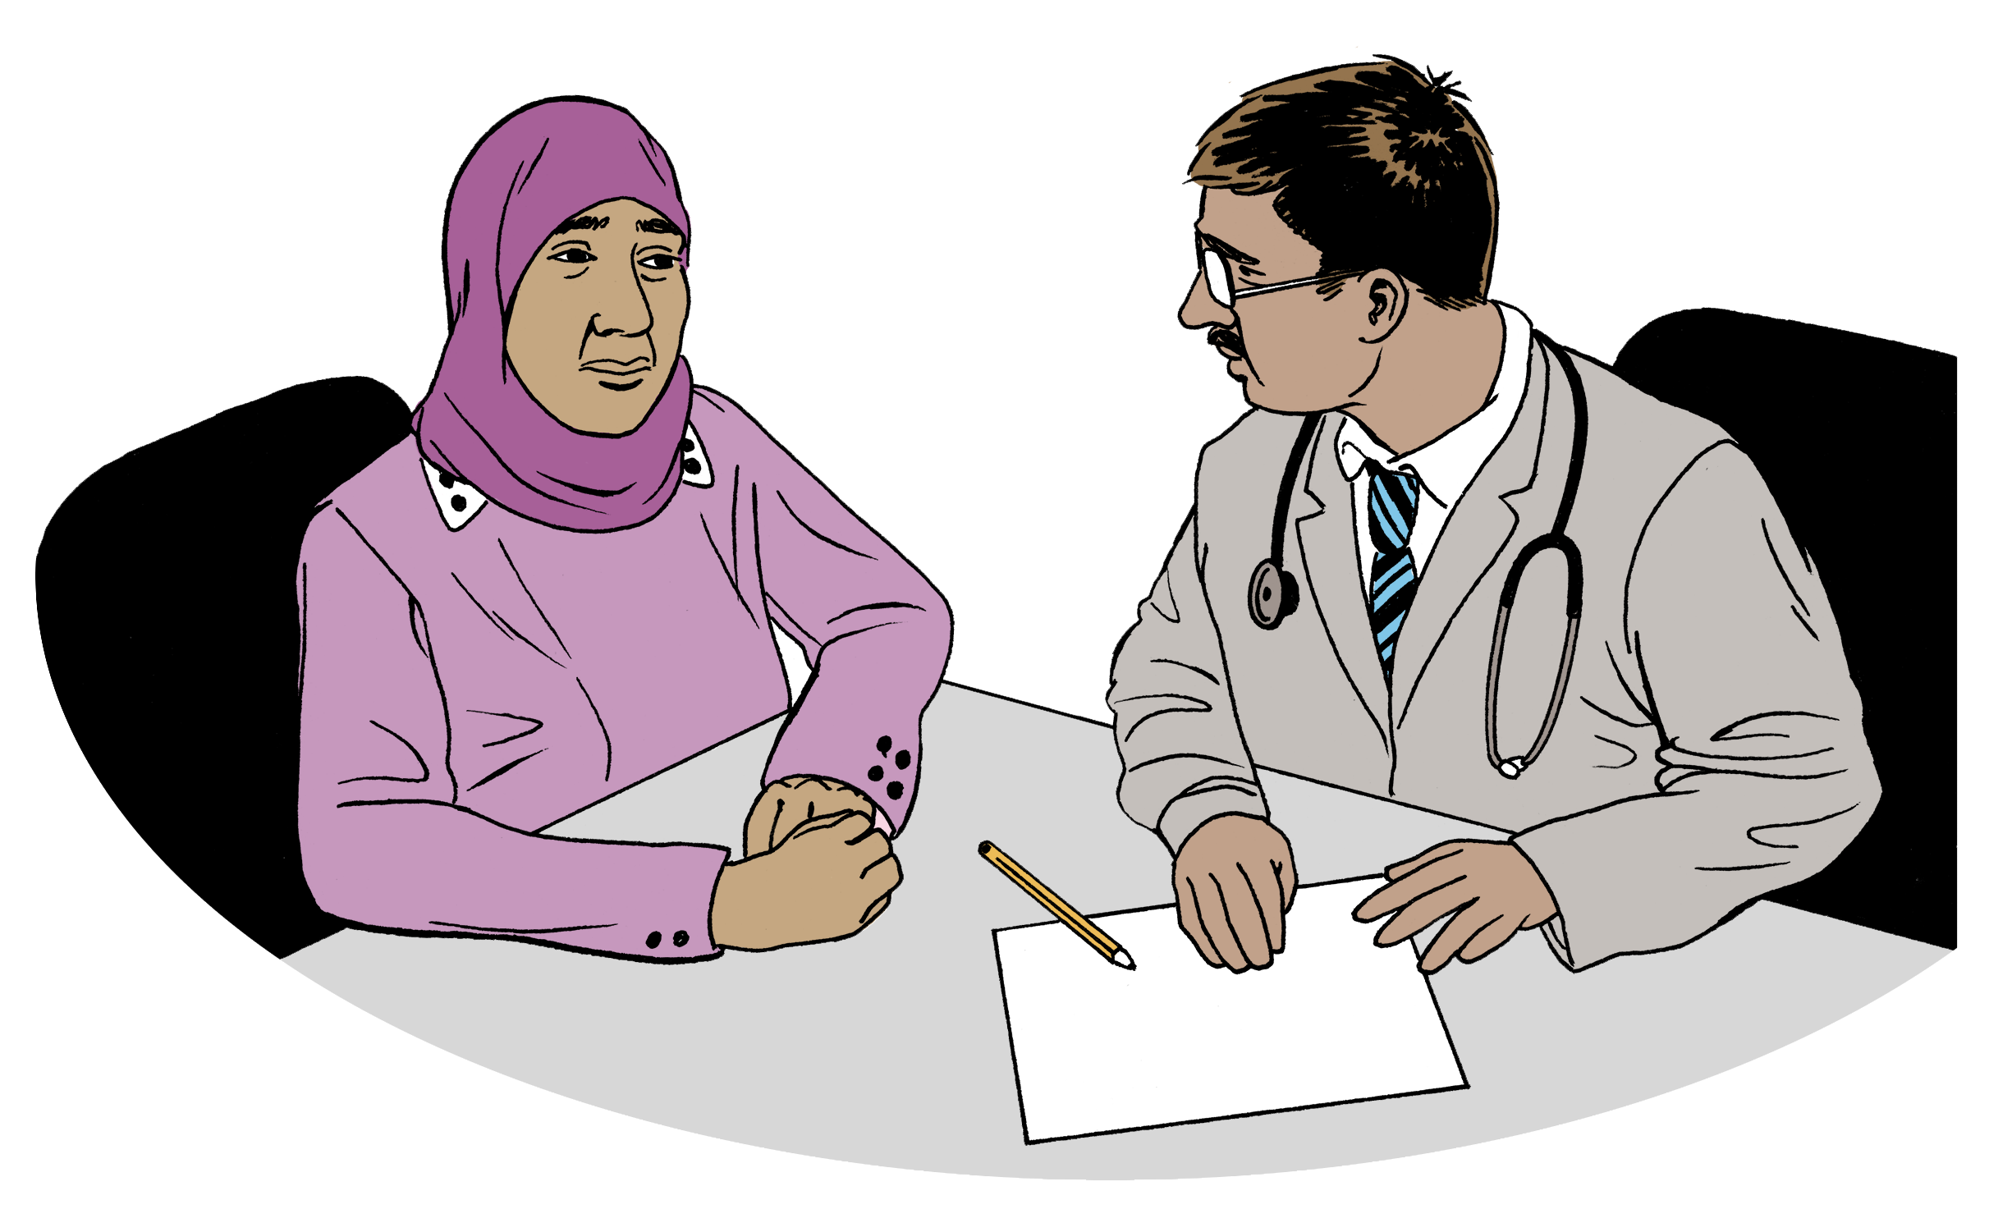
report from:
- an occupational therapist
- a psychologist.

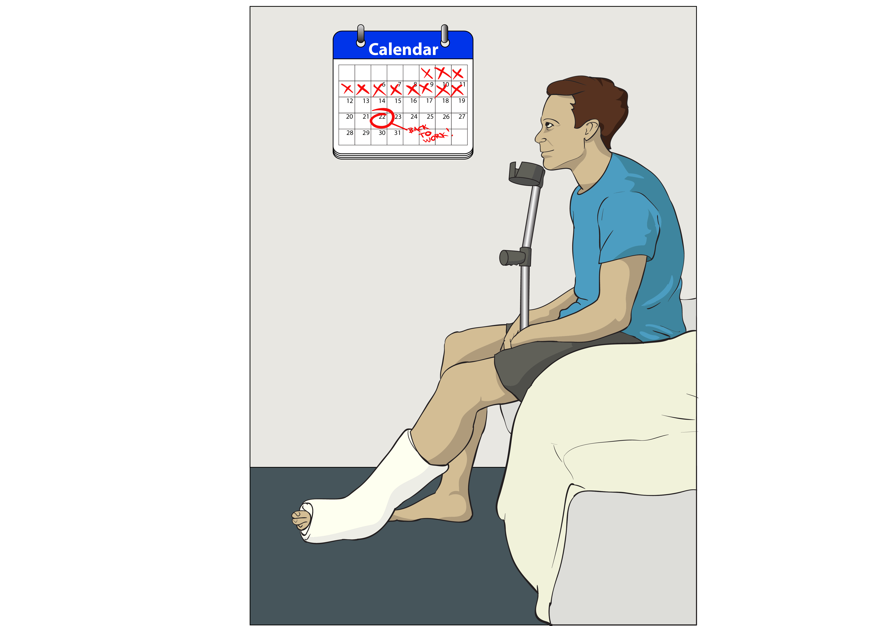
An occupational therapist supports people who:
have been hurt
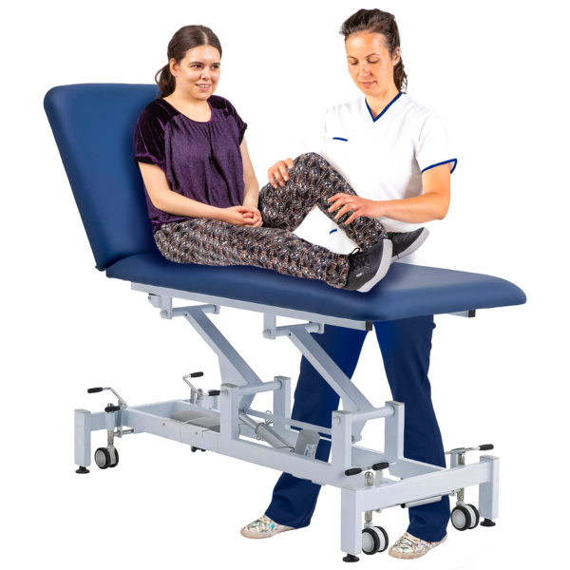
have an illness.
are disabled.

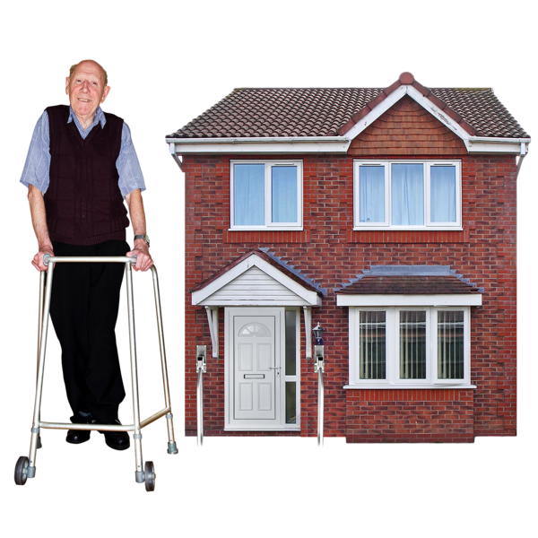
An occupational therapist supports these people to live their everyday life with things like:
skills
equipment.

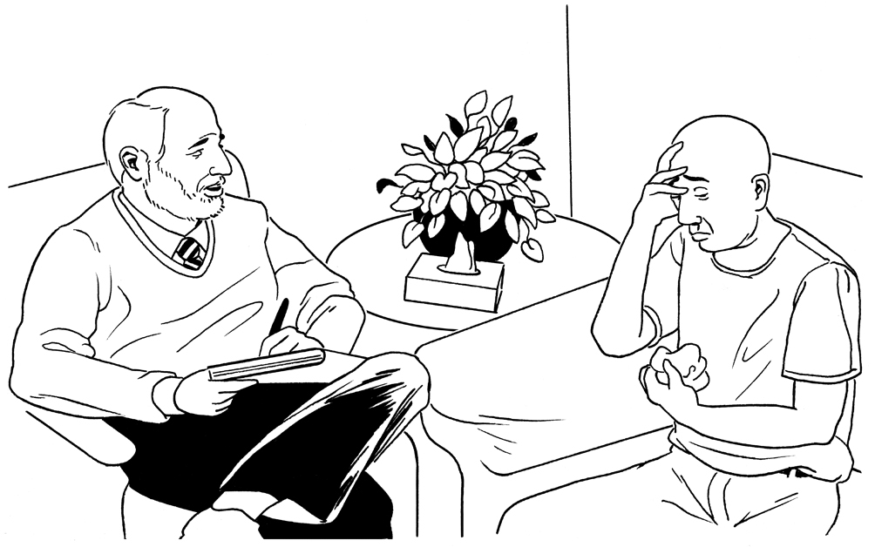
A psychologist supports people to deal with:

their feelings
things that have happened in their lives.
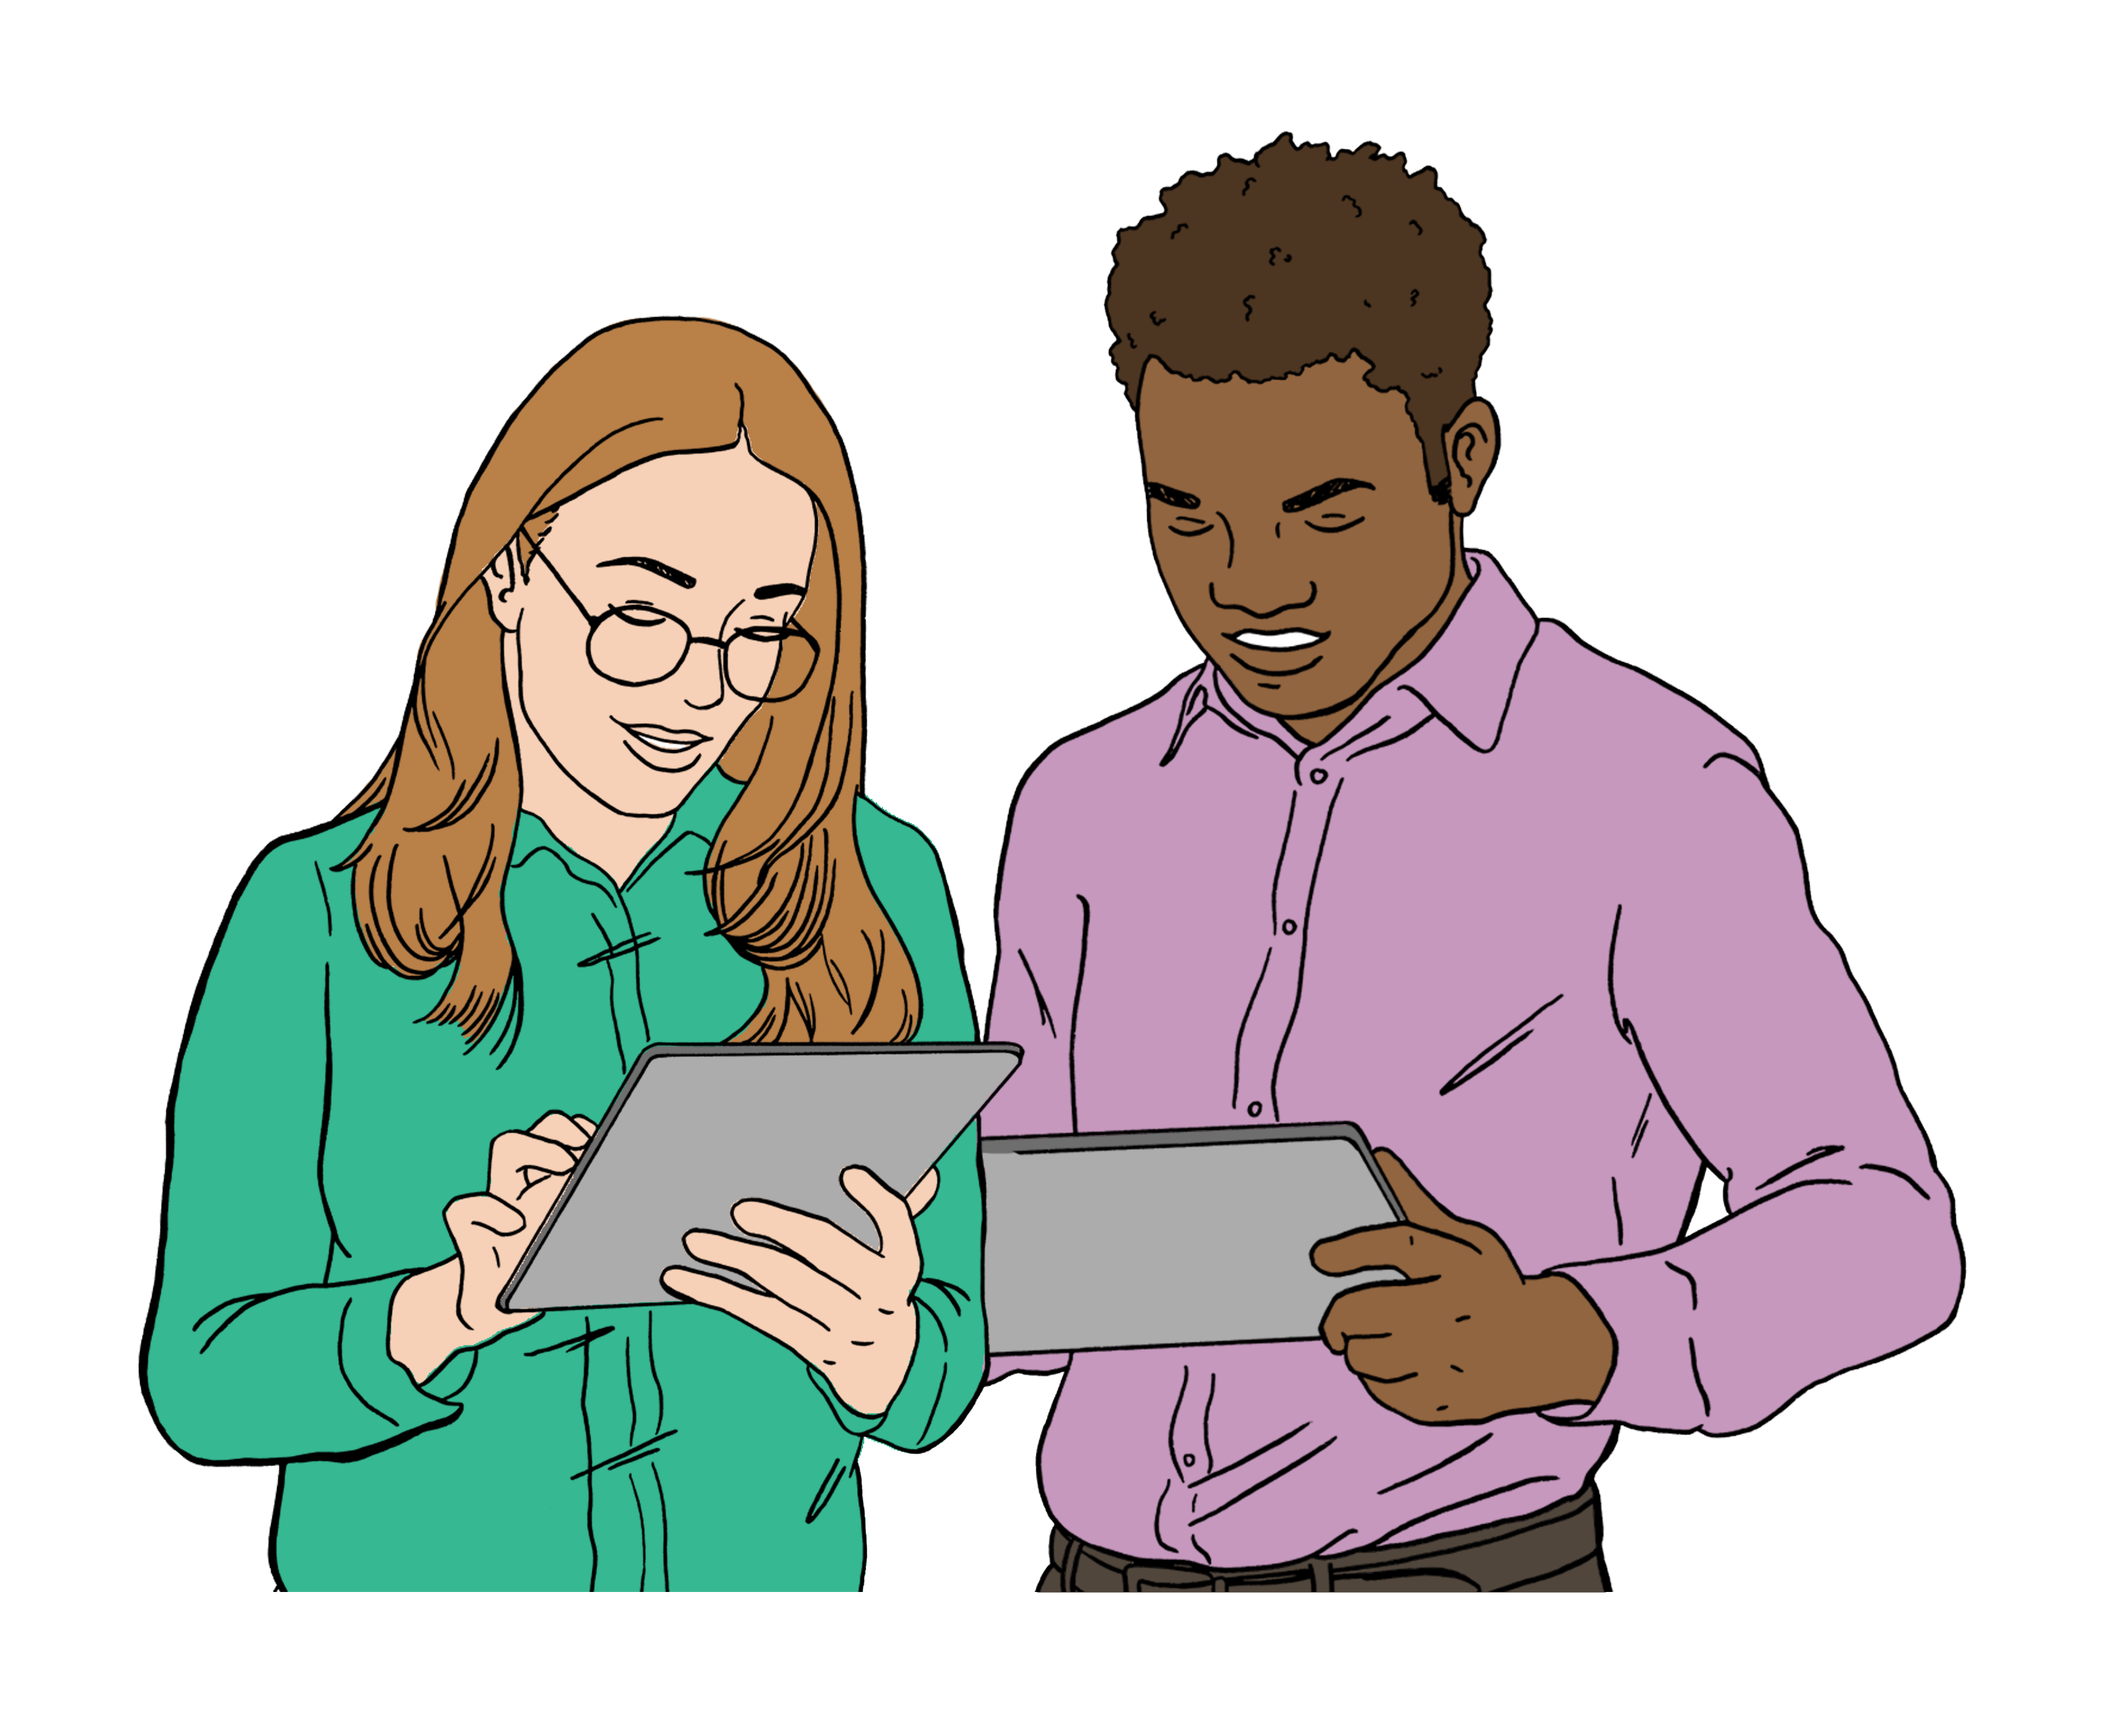
Part of this proposal includes reassessment.

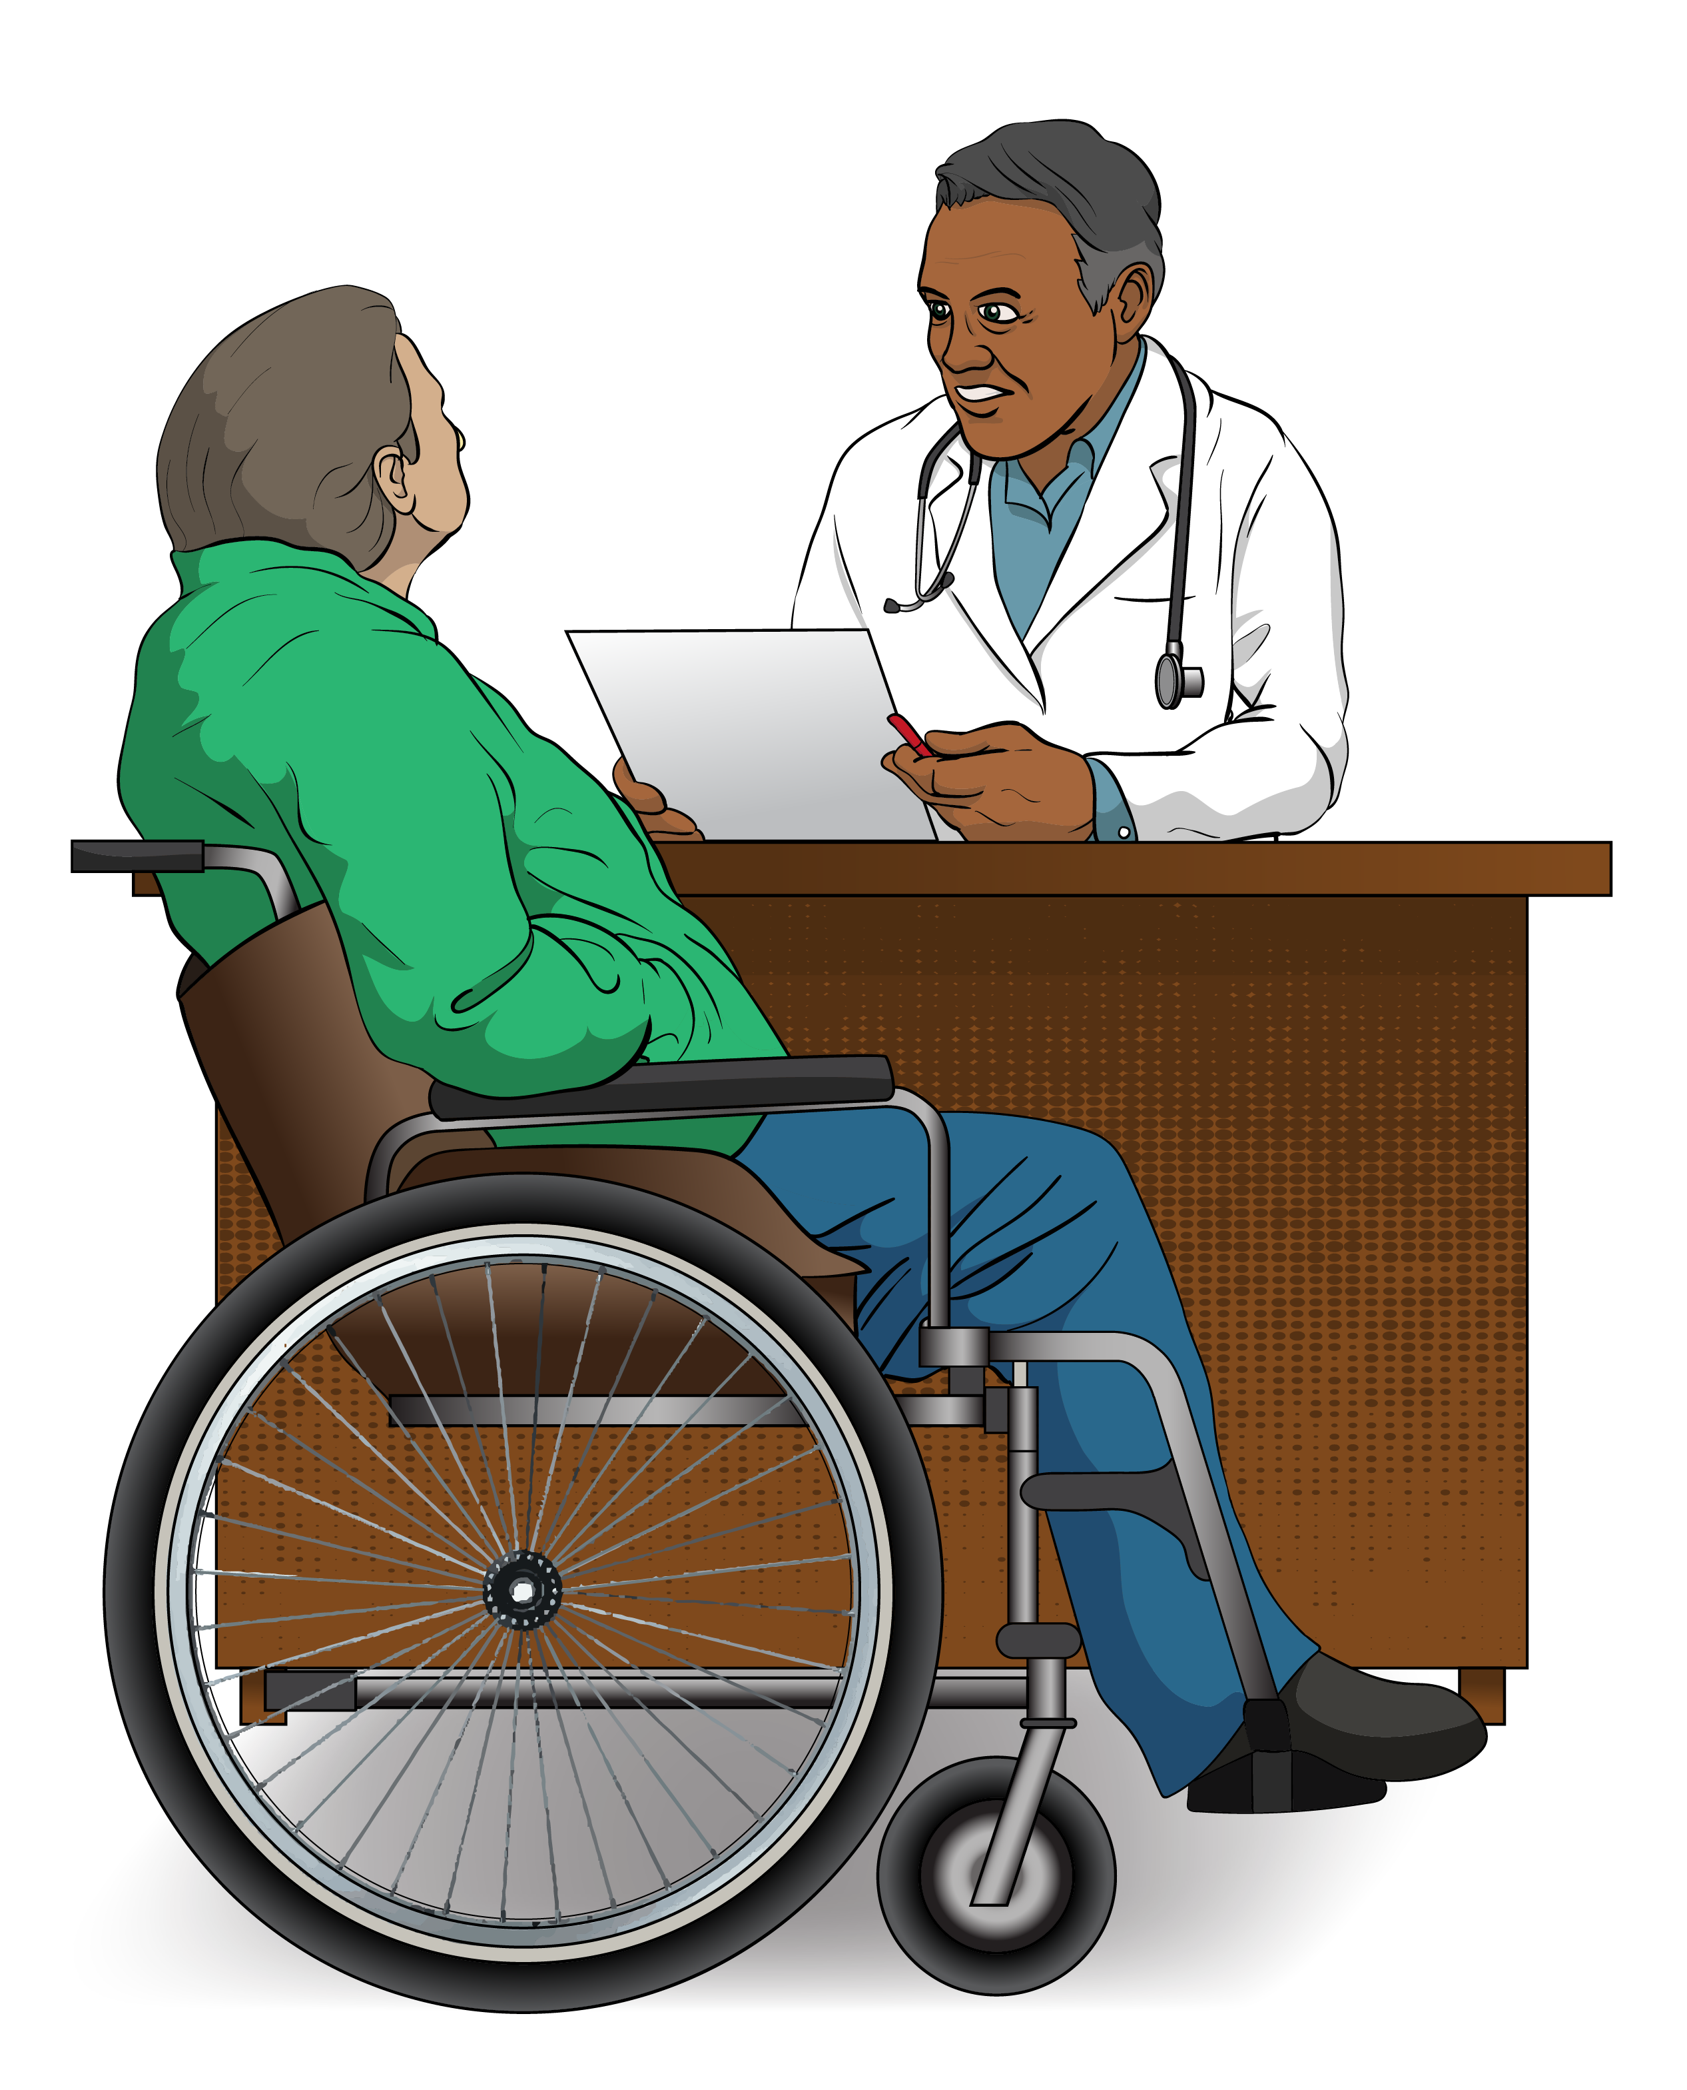
Here reassessment means doing an assessment again to:
make sure things are still correct
check if things might need to change.

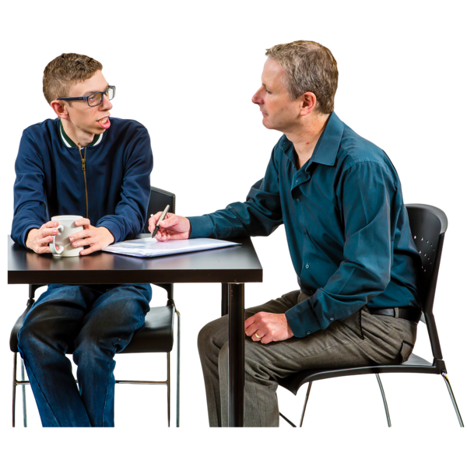
At the moment there is no need for a user to be reassessed for Total Mobility.

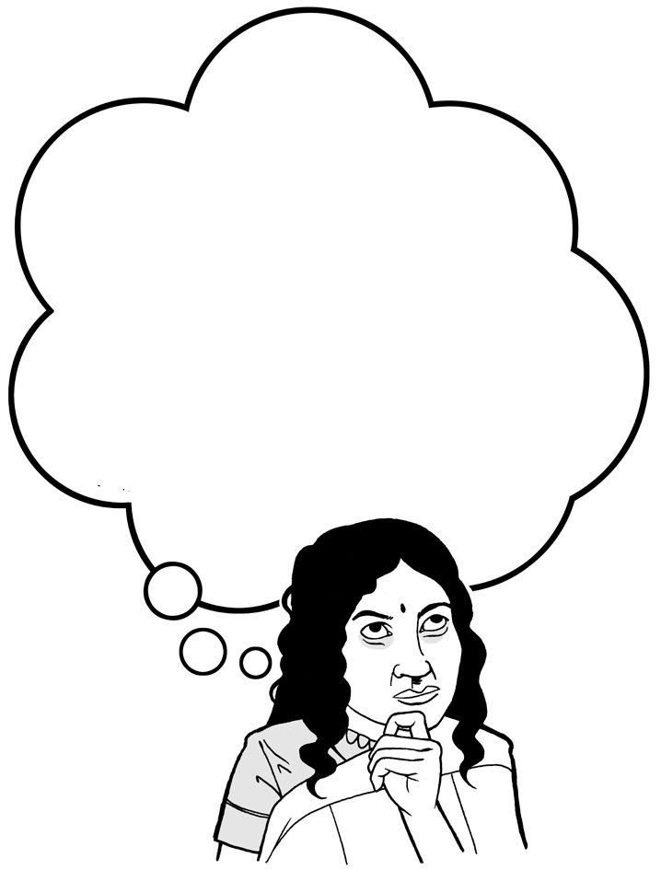

We are thinking about if we should reassess people every few years.

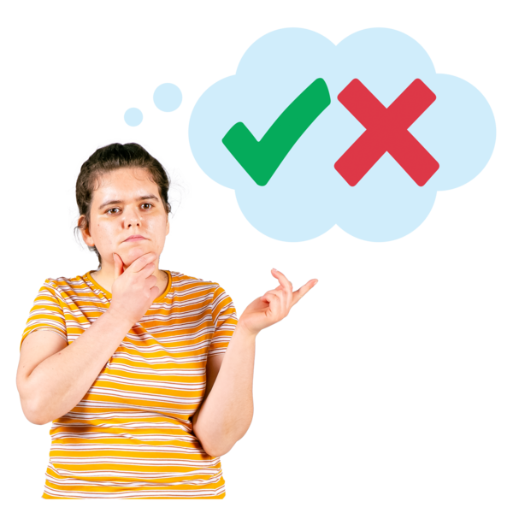
This would be to make sure a person still needs Total Mobility.

Proposal 3: Limit the number of trips.
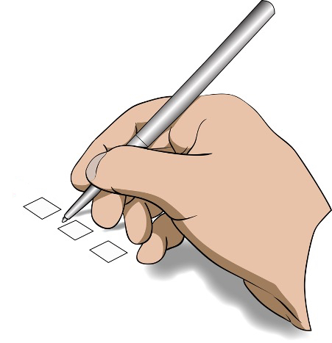
We are thinking about whether we should make a limit / total number of trips a user can do each month using Total Mobility.

This is so we can try to focus support where it is needed.


There are 2 ways this limit / total number of trips could be done.

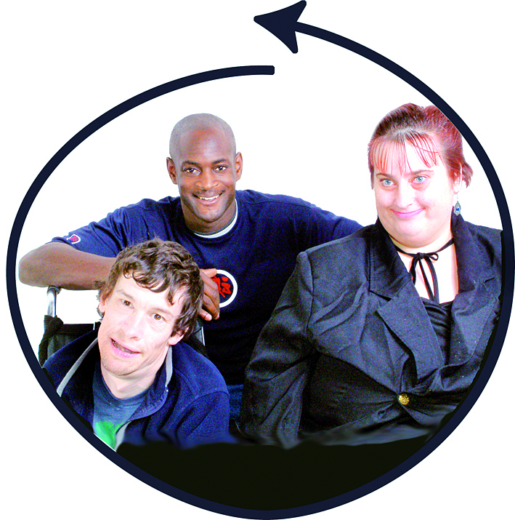
1 way could be that everyone gets the same number of Total Mobility trips.

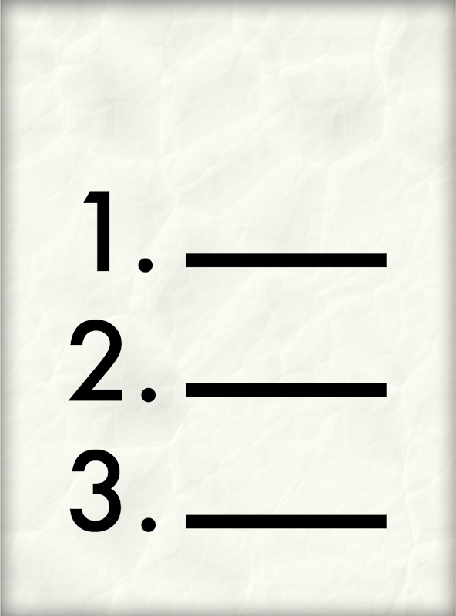
Another way could be that:
everyone gets the same number of Total Mobility trips to start with
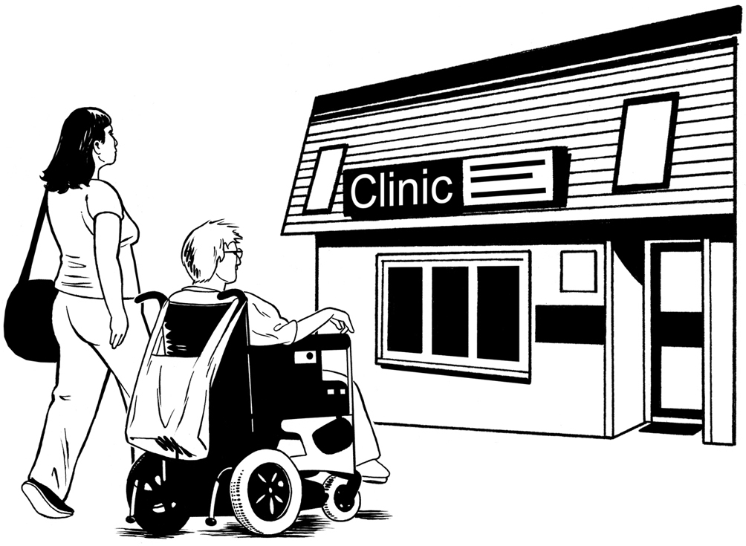
some people get more Total Mobility trips if they need them for things like:
- work
- going to the doctor
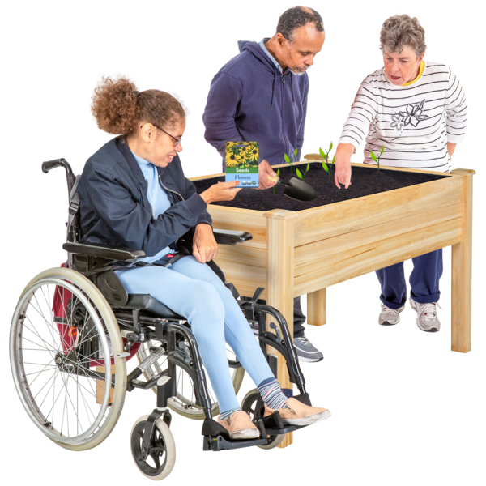
- going to school
- doing community activities like going to an event with a group you are part of.

This would mean that
- not everyone would get the same number of trips
but
- people who need more trips would get more.

Proposal 4: Make more wheelchair accessible trips.

We are thinking about if we should make more supports for wheelchair accessible vehicles.

Here wheelchair accessible vehicles means taxis that can take people in wheelchairs.

This could be things like giving more money to Total Mobility providers to:
put in wheelchair ramps
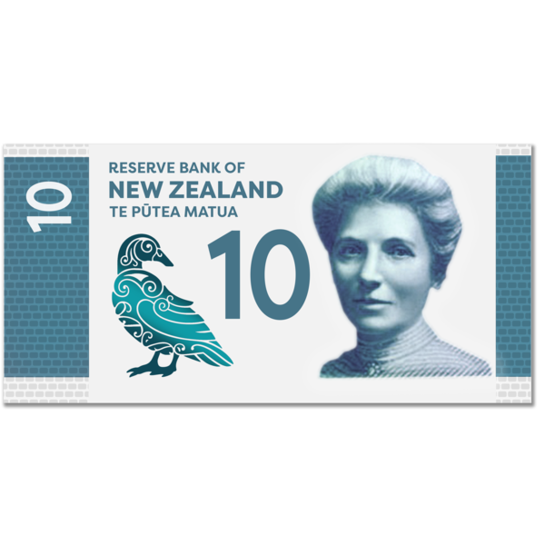
put hoists / lifts in their vehicles
raise / make bigger the extra payment for wheelchair trips.

Proposal 5: Let new providers join Total Mobility.
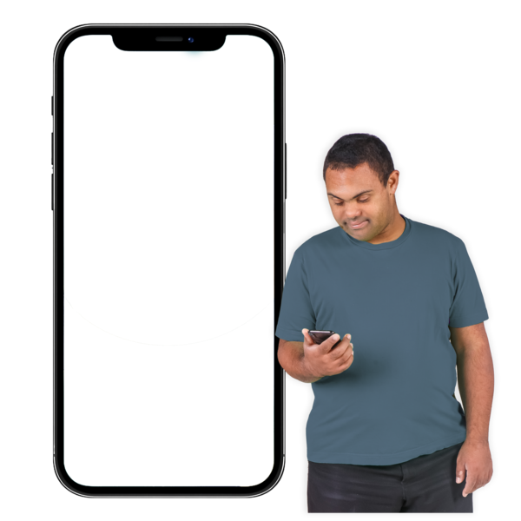
5 minutes
away
We are thinking about if we should make it easier for other providers to join Total Mobility like:
ride-hailing transport like Uber
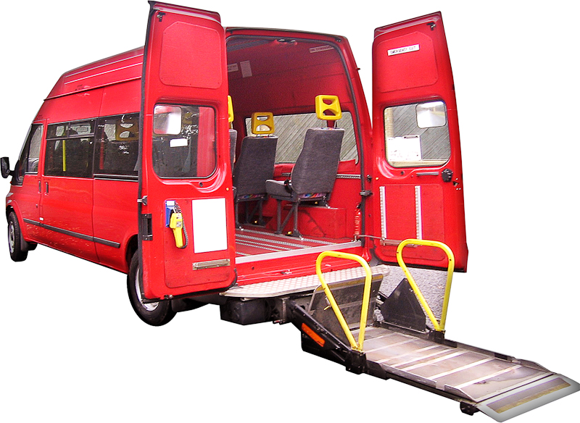
on-demand transport like airport shuttles
community transport.

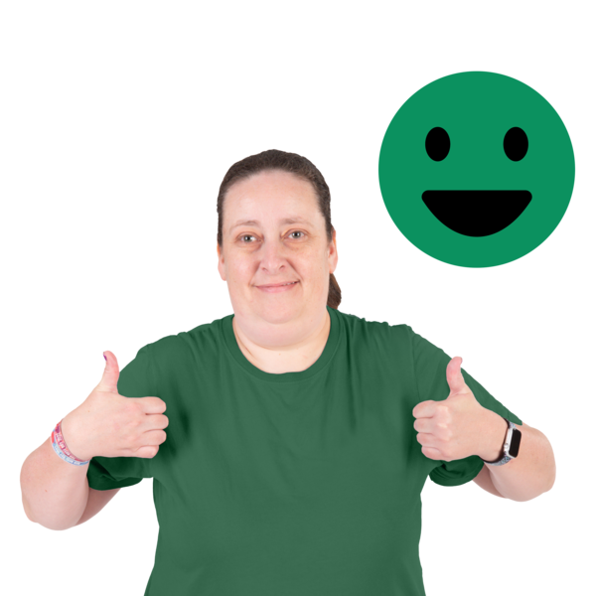
If new providers join Total Mobility we will make sure they are:
safe
easy to use.

Proposal 6: Make public transport cheaper for disabled people across the country.
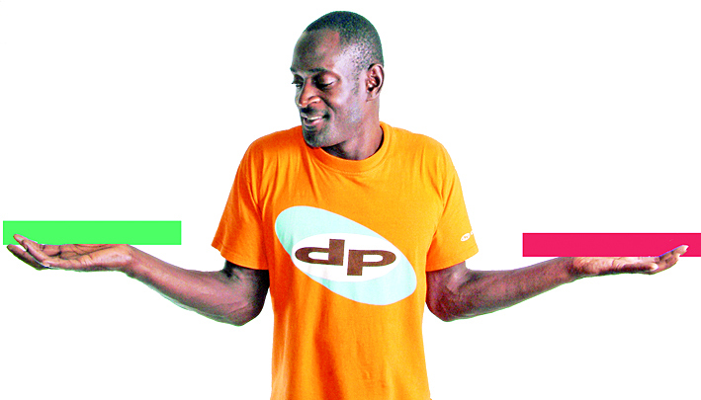

Disabled people can get a discount for using public transport in some parts of the country.


Discount means paying less for something.

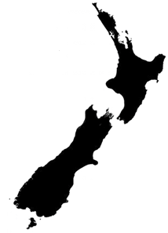
We are thinking about if we should set up a discount for the whole country for disabled people on:
buses
trains
ferries.

How to have your say

You can have your say about the Total Mobility scheme now.

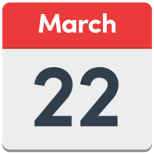
You need send us your feedback by
22 March 2026.

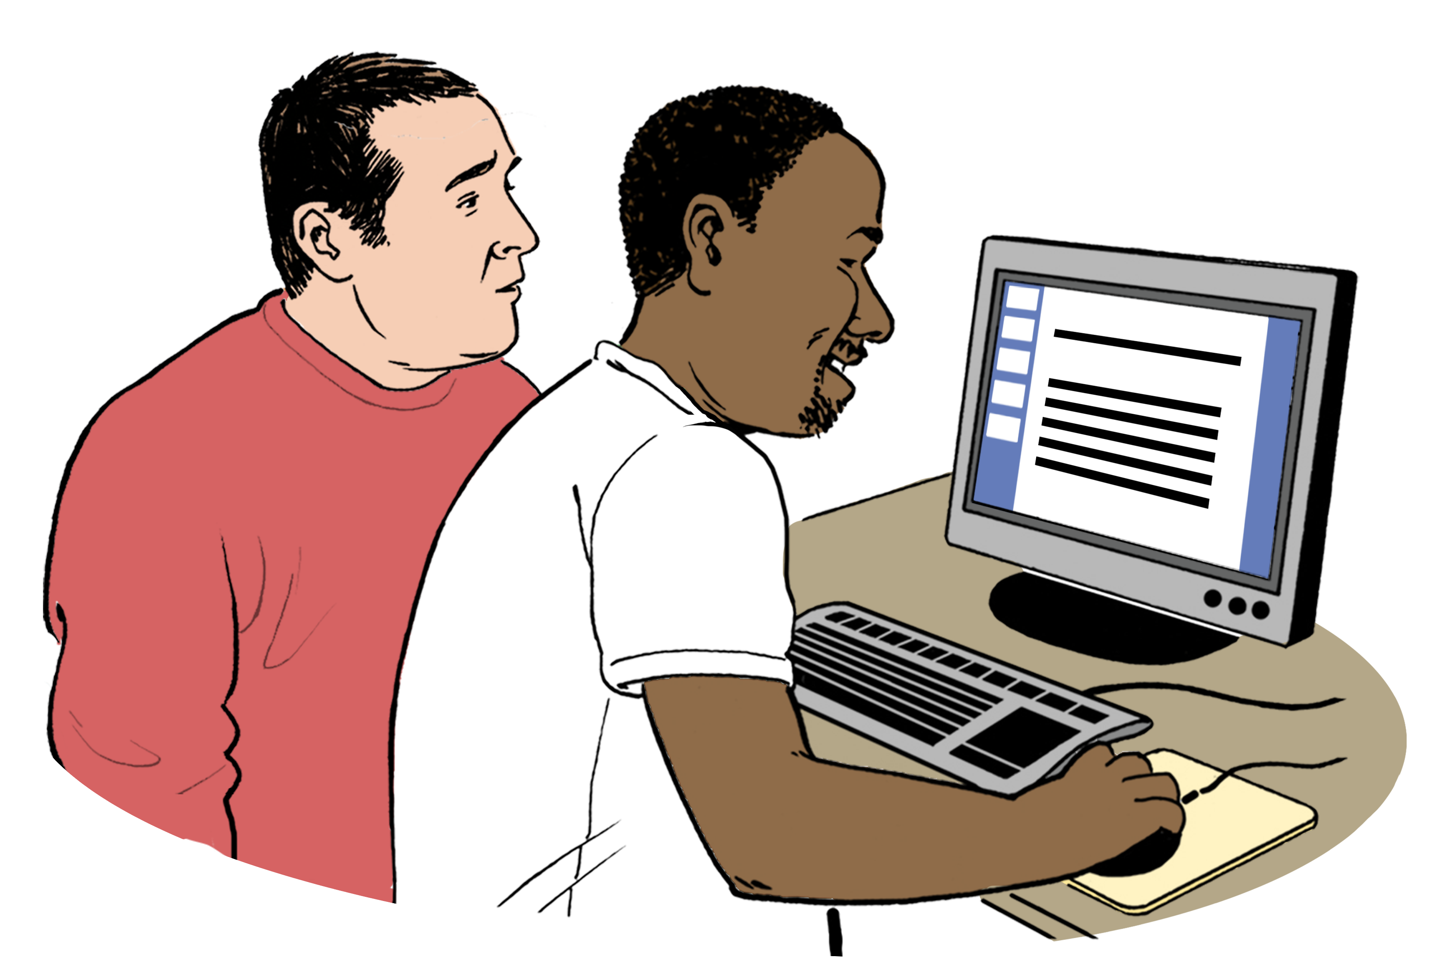
You can give your feedback at this website:

https://tinyurl.com/bdfhb5vz

This website:
- is not in Easy Read
- will be set up in Easy Read in January 2026.

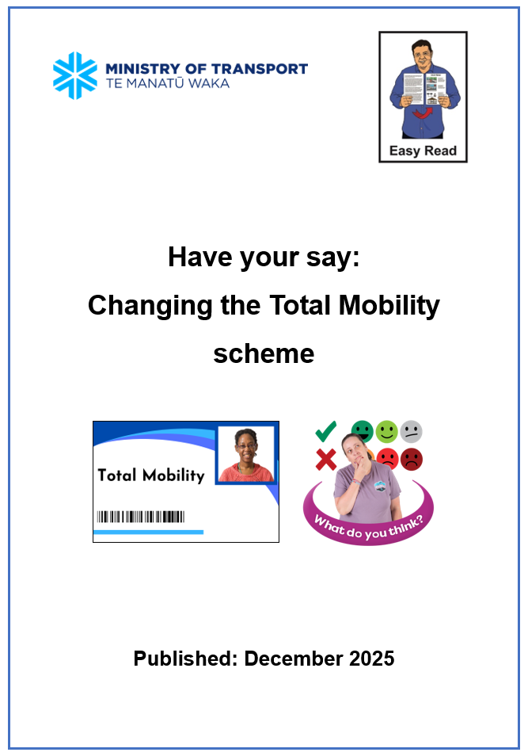
You can have your say by using the Easy Read Have your say: Changing the Total Mobility scheme:

https://tinyurl.com/36jzta2j

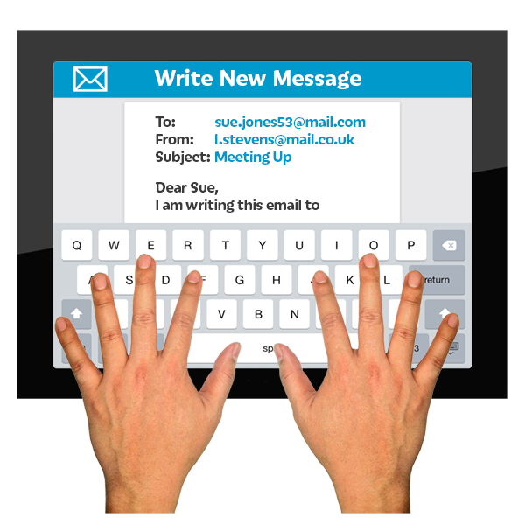
You can send your feedback by email:

TotalMobilityReview@transport.govt.nz

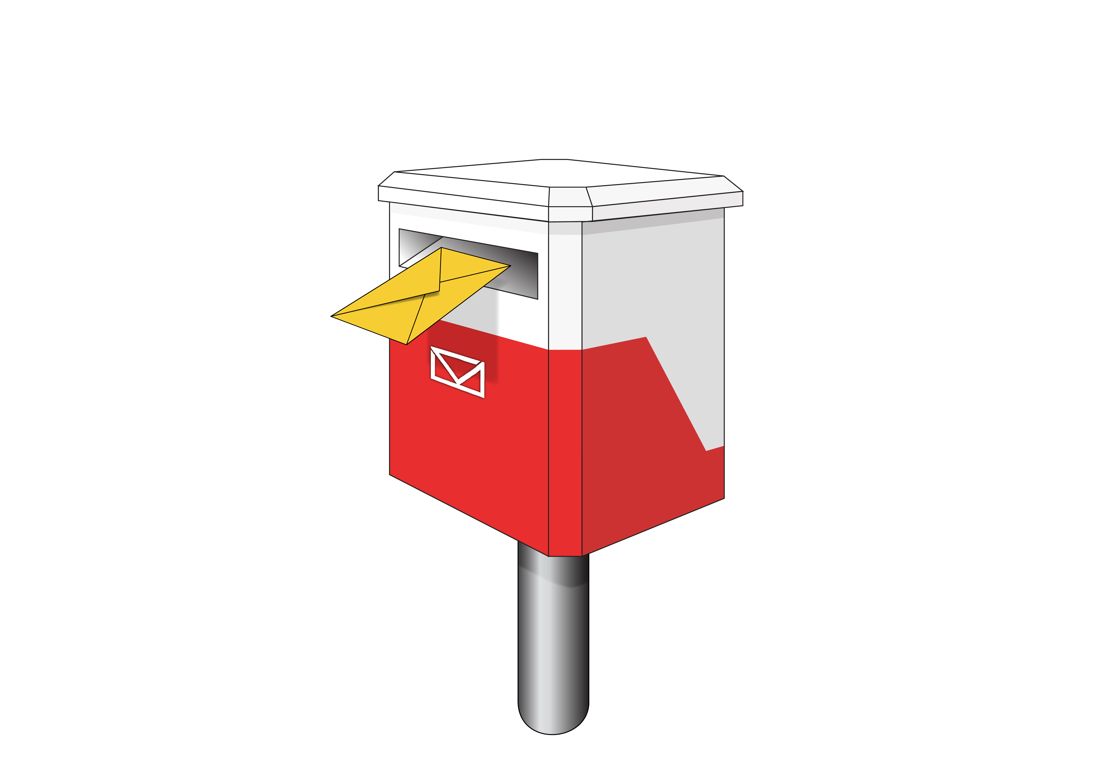
You can send your feedback by post:

Total Mobility Consultation

Ministry of Transport

PO Box 3175

Wellington 6140
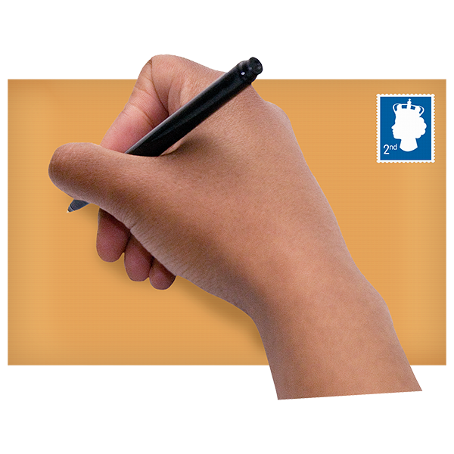

You will need to put a stamp on your envelope.
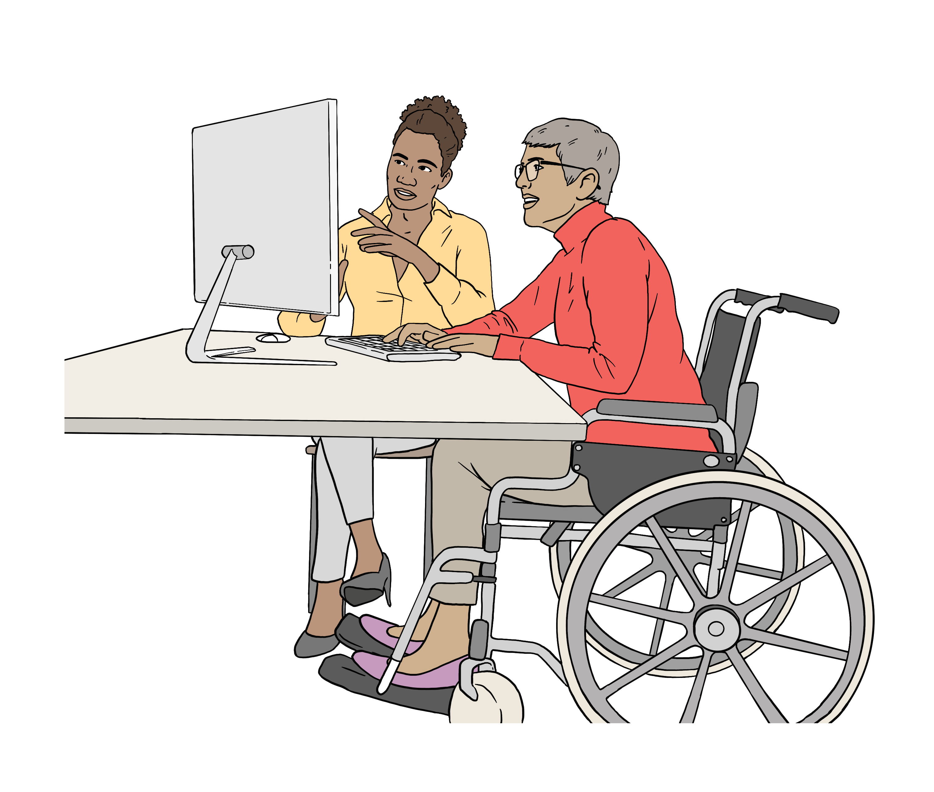
Submissions / feedback about the Total Mobility scheme may:
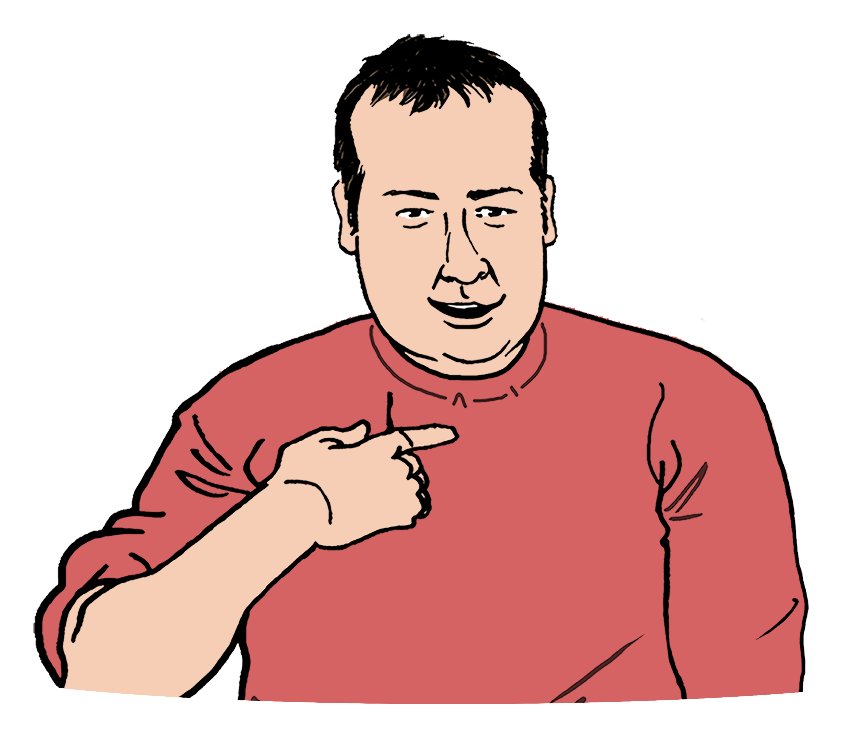
be put out for the public to read
show who you are.

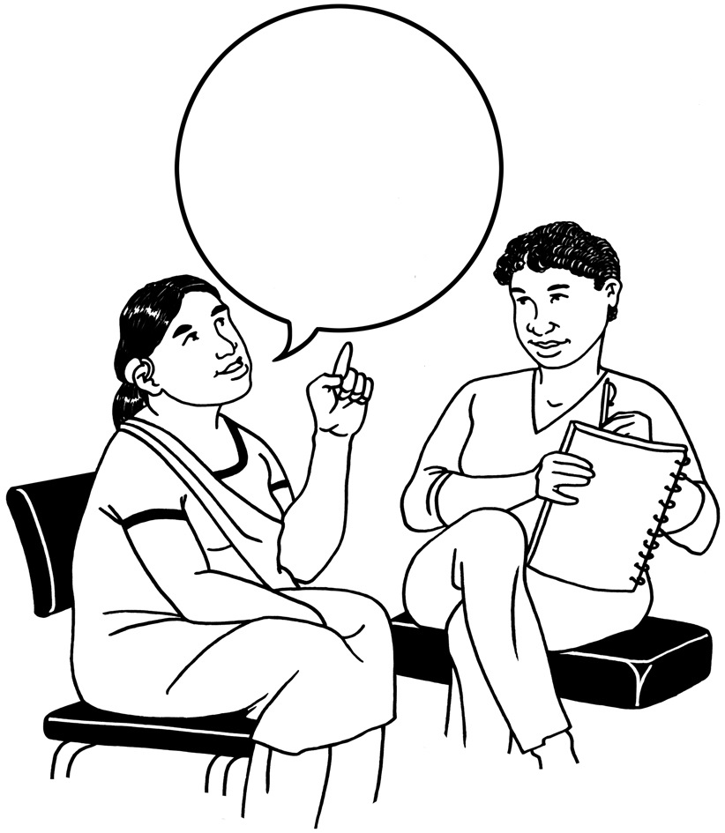
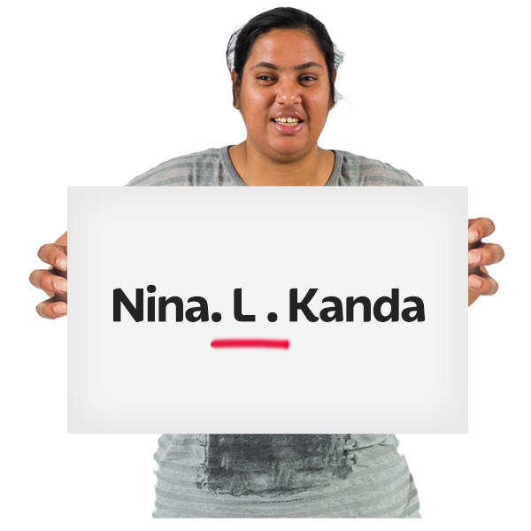
Please say clearly on your submission / feedback if you do not want us to share your:
name
comments.


We may use
Artificial Intelligence / AI to look at submissions / feedback.


Artificial Intelligence / AI is a way computers can:
put together lots of information
learn to do things.

We will not put information about you into the Artificial Intelligence / AI system we are using.


This information has been written by the Ministry of Transport Te Manatū Waka.

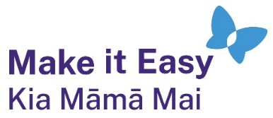
It has been translated into Easy Read by the Make it Easy Kia Māmā Mai service of People First New Zealand Ngā Tāngata Tuatahi.

The ideas in this document are not the ideas of People First New Zealand Ngā Tāngata Tuatahi.

All images used in this Easy Read document are subject to copyright rules and cannot be used without permission.


Make it Easy uses images from:

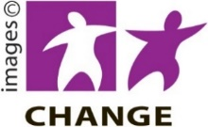
- Photosymbols

- Change Images


- Huriana Kopeke-Te Aho

- SGC Image Works

- T Wood


- Studio Rebeko

- Inga Kramer.

