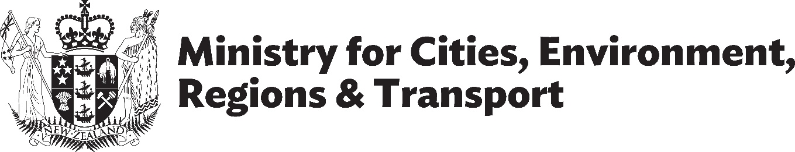
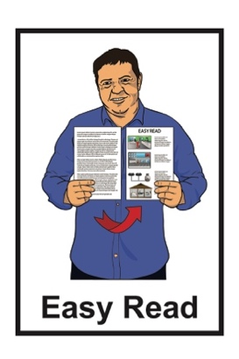

Total Mobility update – August 2026
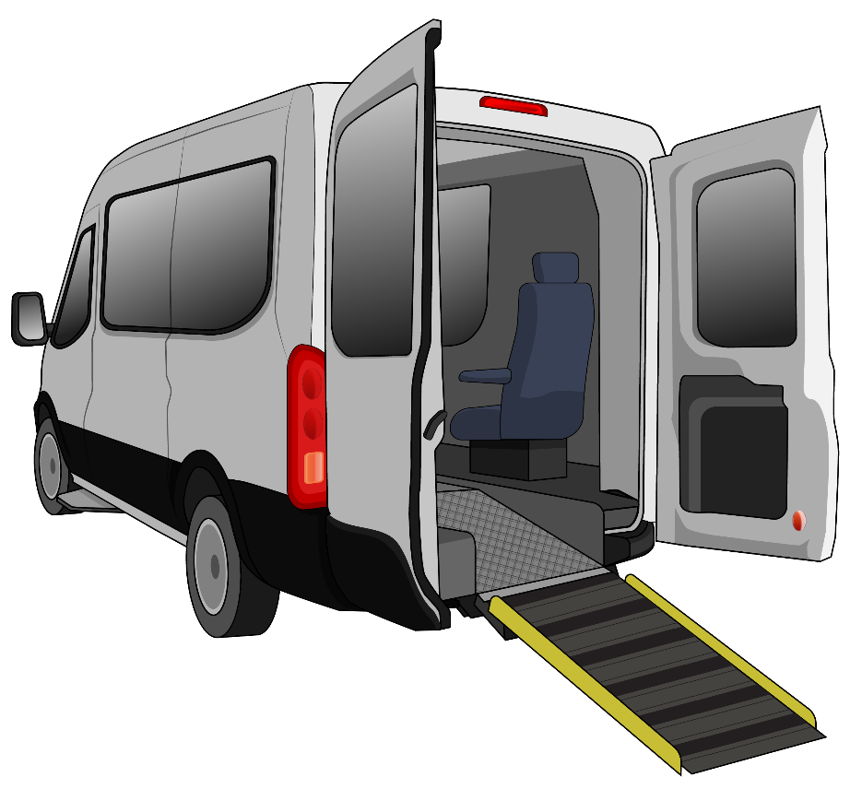
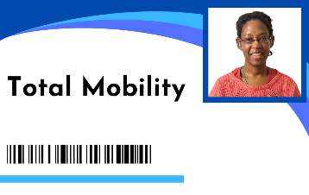

Published: August 2026

About this Easy Read


This Easy Read is from the
Ministry for Cities, Environment, Regions & Transport.

The Ministry for Cities, Environment, Regions & Transport is also called MCERT.

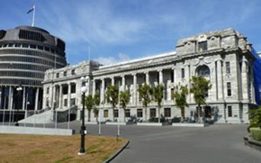
MCERT is a new Government agency that started on 1 July 2026.


You can find more information about MCERT at this website:

www.mcert.govt.nz

This Easy Read is about changes to the Total Mobility scheme.


The Total Mobility scheme
supports disabled people to move around by paying part of the cost of taxi trips.

Disabled people can use Total Mobility if they cannot use public transport on their own.

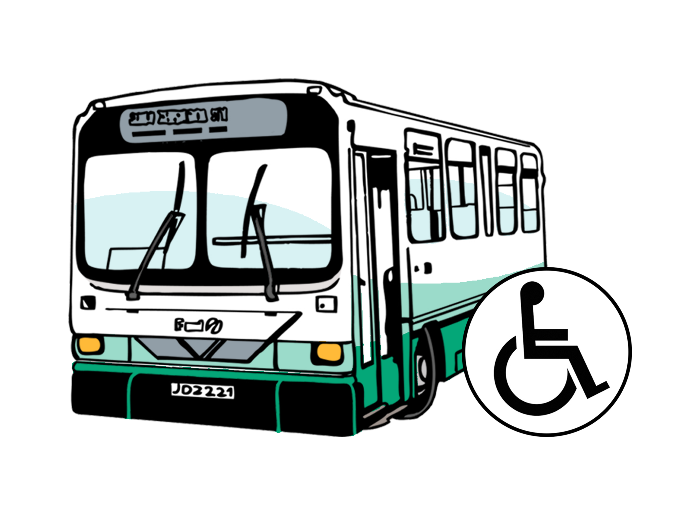
In some parts of Aotearoa New Zealand the Total Mobility scheme can also make public transport cheaper for disabled people.

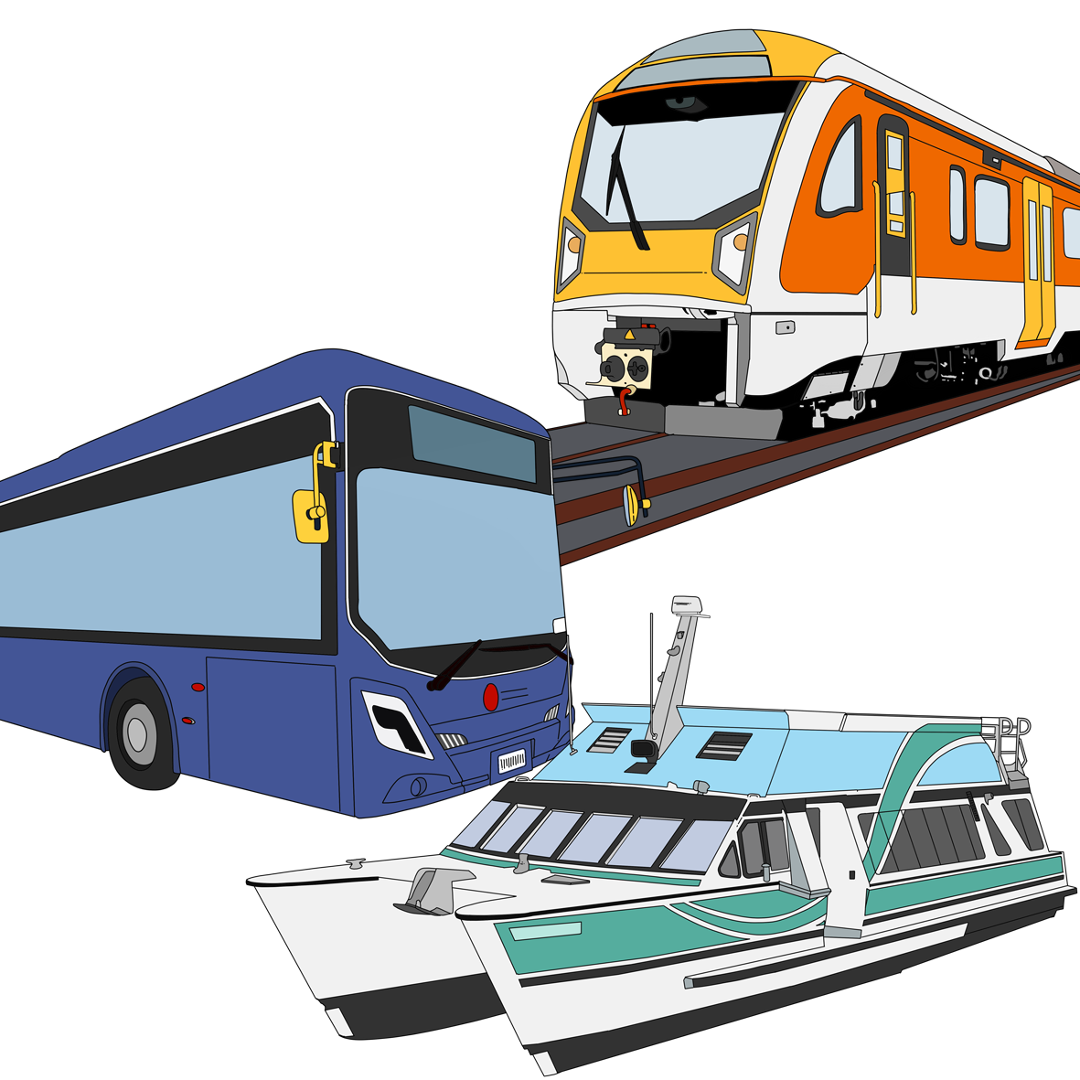
Public transport means transport within a local area by:
- buses
- trains
          - ferries.

The Government ran a public consultation from December 2025 to March 2026.

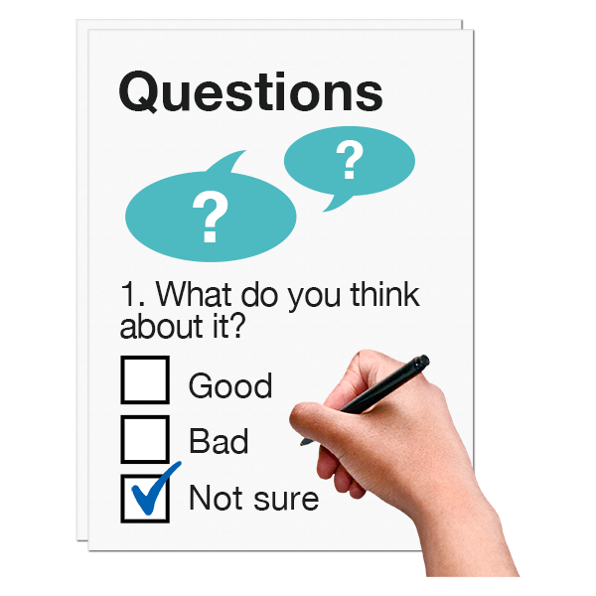
A public consultation is when the Government asks people what they think about some ideas.

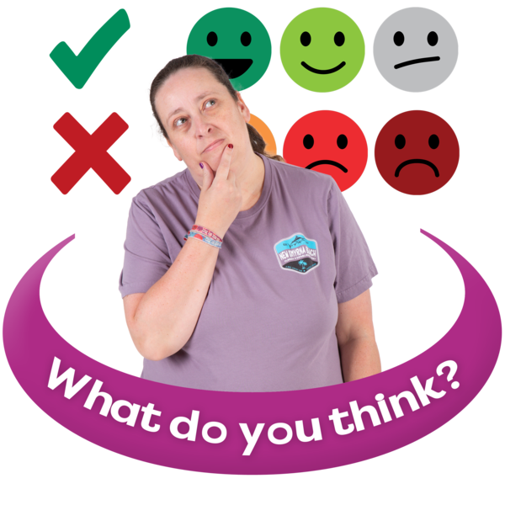
For this public consultation people were asked about some ideas for how the Total Mobility scheme could work better.

When we use the words we / us this means MCERT.

Using what people told us in the public consultation we are now making some changes to the
Total Mobility scheme.

Changes to the Total Mobility scheme

This Easy Read is a summary of the changes we are making to the Total Mobility scheme.


A summary:
is shorter than the main document
tells you the important ideas.

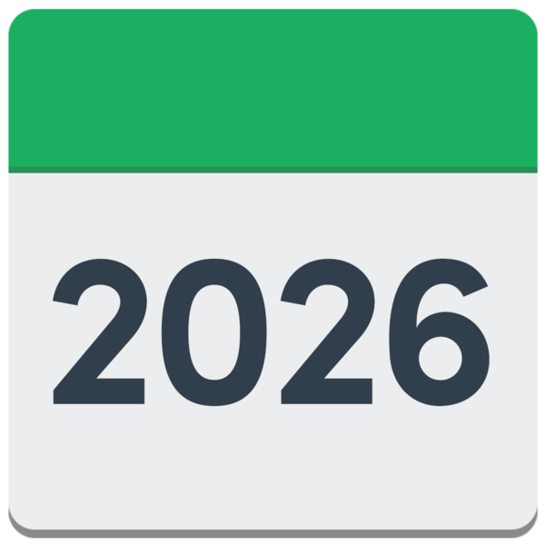
The changes will be worked on in:
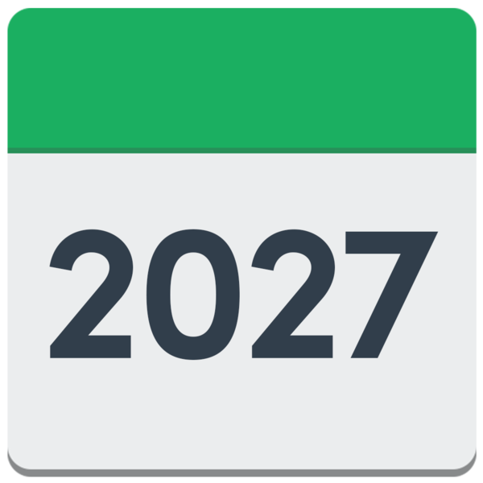
- 2026
- 2027.


There are 4 main changes the Government will work on to make the Total Mobility scheme better.

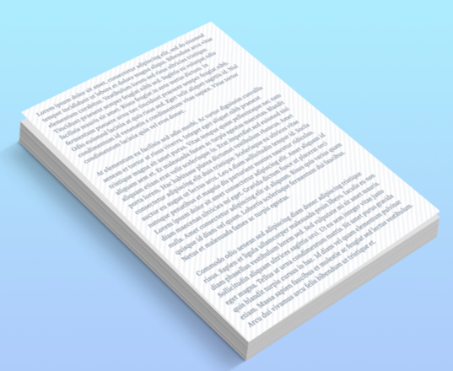
- Have a national purpose statement

A national purpose statement explains:
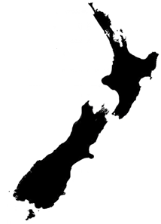
- what the Total Mobility scheme is for
- how it should work across Aotearoa New Zealand.

The new national purpose statement is:

To provide subsidised, accessible transport options to disabled people, and people living with
long-term impairments, who are unable to access public transport, to live their lives and participate in work, education, and their community.


Here subsidised means the government pays part of the cost.

Participate means to:
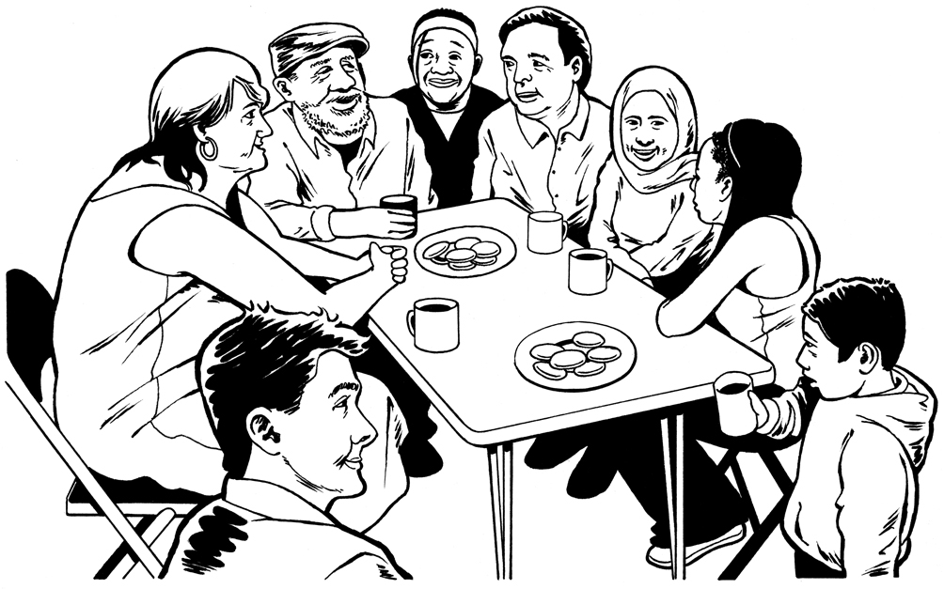
be part of something
do things as part of something.

- Review funding for wheelchair accessible vehicles

The New Zealand Transport Agency will review funding for wheelchair accessible vehicles like wheelchair accessible taxis.


The New Zealand Transport Agency is a Government agency.


Review means to:

- look at something closely

- suggest ways of changing things.

Total Mobility providers get an extra payment when someone uses their service with a wheelchair.

Providers are the businesses that provide transport through the Total Mobility scheme.


Part of the review will look at giving more money to Total Mobility providers so this extra payment can be made bigger.


- Review the rules for Total Mobility providers

The New Zealand Transport Agency will review the rules for Total Mobility providers.


They will look at whether more types of transport providers could join the Total Mobility scheme.


This could include ride-hail services like Uber.

Ride-hail services means transport where:

you book using a mobile phone app
the drivers use their own cars.

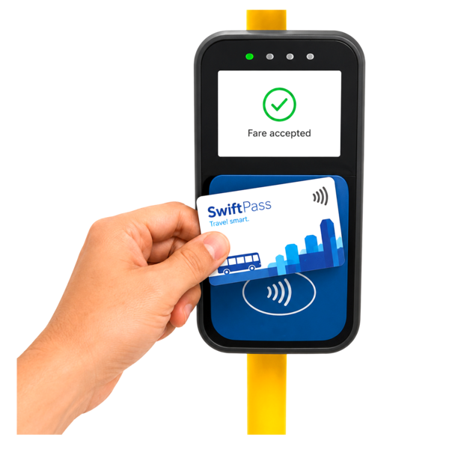
- The Government will do more work on a national public transport discount for Total Mobility users
National means across all Aotearoa New Zealand.


Discount means paying less money for the public transport fare.

This work will also look at free travel for a companion.
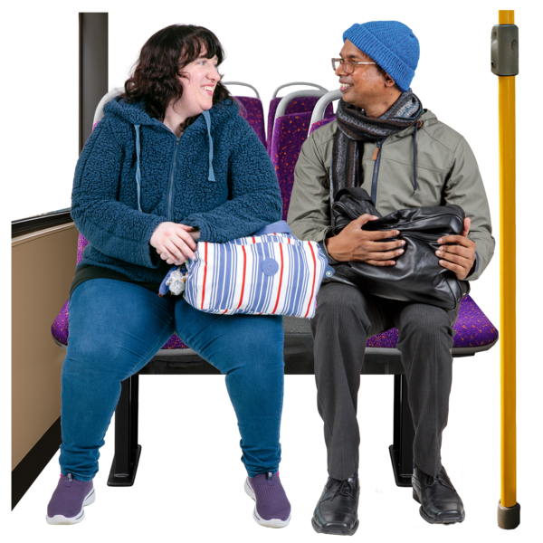

Companion means a person who travels with someone to support them.

What the Government will not be changing


The Government has decided not to make some changes.


The Government will not:
- ask for more proof about an impairment / disability a person has
- ask for reassessments for everyone
- set a limit on the number of trips people can make using the Total Mobility scheme.

Here an assessment means telling someone about your disability so they can decide if you can use Total Mobility.


Reassessment means doing an assessment again to:
make sure information about you is still correct
check if things might need to change.


The feedback from the public consultation found that these ideas could create more:
- costs – people would need to spend more money
- barriers – make it harder for people to use the Total Mobility scheme.

Where to find more information


You can find more information about the changes to the Total Mobility scheme on the Ministry of Transport of website:
https://tinyurl.com/y2vj7cvh

MCERT is still working on having this information on their website.
This information has been written by the Ministry for Cities, Environment, Regions & Transport.

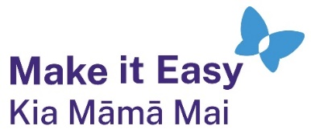
It has been translated into Easy Read by the Make it Easy Kia Māmā Mai service of People First New Zealand Ngā Tāngata Tuatahi.

The ideas in this document are not the ideas of People First New Zealand Ngā Tāngata Tuatahi.

All images used in this Easy Read document are subject to copyright rules and cannot be used without permission.


Make it Easy uses images from:


- Photosymbols

- Change Images


- Huriana Kopeke-Te Aho

- SGC Image Works

- T Wood


- Studio Rebeko

- Inga Kramer.

